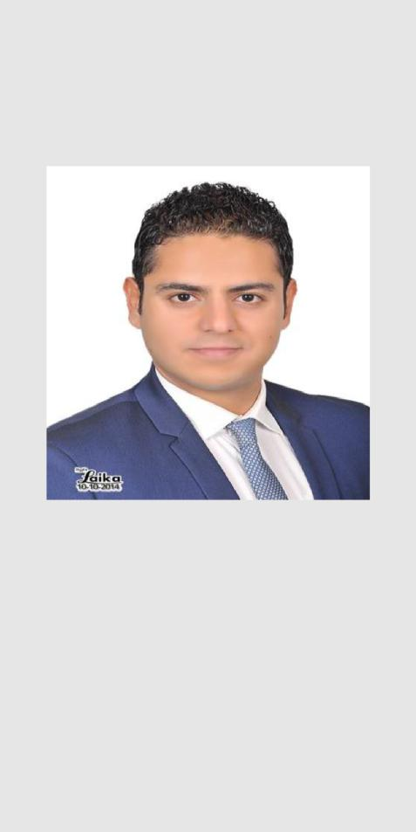

Elazab

ABU DHABI

UAE

Elazab.366767@2freemail.com

ABOUT ME

An enthusiastic, articulate and well-presented medical sales representative who has a successful sales track record in healthcare or pharmaceuticals. Highly efficient and currently working as part of a successful team .

PERSONAL SKILLS

- Social skills

- Ambitious

- Patient

- good communication skills
- very organized

ELAZAB

MEDICAL REPRESENTATIVE

EXPERIENCE

(may 2016 – present)

MEDICAL REPRESENTATIVE

ABBOTT UAE

(jan 2016 – april 2016)

EXECUTIVE MEDICAL REPRESENTATIVE
NOVARTIS EGYPT

(Sep 2014 – dec 2015)

ADVANCED MEDICAL REPRESENTATIVE
NOVARTIS EGYPT

EDUCATION

(2009 – 2014)

BACHELOR OF PHARMACY

GERMAN UNIVERSITY IN CAIRO

WORK SKILLS

- Possess the ability to influence a positive sales outcome with a customer.

- Having the necessary confidence, initiative, motivation and reliability to succeed.
- Able to identify & hunt down sales opportunities.

- Experience of selling to district, tissue viability & vascular nurses.

- Comfortable with target customer call rate and message retention metrics.

REFERENCES Available on request.

