Curriculum Vitae
SURYA
SURYA.366773@2freemail.com 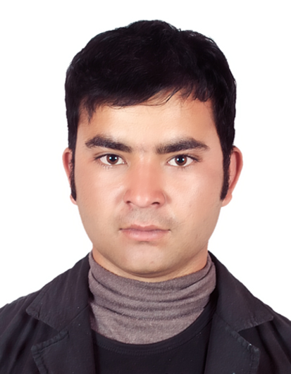
OBJECTIVE
To pursure a challenging career in a reputable organization and provide competitive work with opportunities for personal growth and career advancement.
QUALIFICATION
- Higher secondary education certificate from Shree Ganga Higher secondary school, Nepal
- Security Tranning.
- State security guard officer card license.(DPS)
WORK EXPIRENCE
1. Current- As a security officer, East Coast Security llc, UAE
2. Past- As a recreation supervisor, QATAR
3.Past- As an armed police force, Nepal
PERSONAL DETAILS
Nationality : Nepal
Date of Birth : 21 May 1991
Gender : Male
Marital Status : Single
Language Known : Hindi/Nepali/English/Tamil

KEY SKILLS
- Strong interpersonal and communications skills-effectively interact with the people of different ages and culture.
- Hard working, Punctual & Optimistic.
- Good learning & Listening Abilities.
- Learn quickly, and able to work under pressure.
- Provide excellent service always using assertive behavior with customers.
- Results-Oriented, self-starter with experience.
- Can work independently and in a team.
ACHIEVEMENTS
- Two times employee of the month in recreation department, Qatar
- Well trained as an armed police force, Nepal
DECLARATION
I assure that the above information and details furnished by me is true and accurate to the best of my knowledge.

