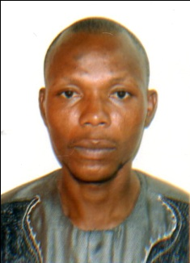
KABIR
KABIR.366782@2freemail.com

Career Objective:
To be engaged in a reputed work that will provide opportunities for integration and application of professional and management skills and a challenging position which will harness my full potential and offer self-fulfillment and self advancement wherein i could contribute to the growth of the company.
Educational Qualification:
- Ordinary National Diploma - 2004
- West Africa Senior School Certificate - May/June 2002
- West Africa Senior School Certificate - Nov/Dec 2002
- First School Leaving Certificate - 1992
Languages Known:
- English
- Yoruba
Religion:
- Islam
IT Knowledge:
- MS-office
- Internet Research
Experience:
- Worked as a Computer Engineer and Maintenance Officer at TEBOK COMMUNICATIONS ENTERPRISES in Lagos, Nigeria(2005-2009).
- Worked as an Assistant Sales and Marketing Manager at KABEERULLAH GLOBAL RESOURCES LIMITED in Lagos, Nigeria (2009-2014).
- Worked as an Assistant Sales Manager and Store Keeper at A 5IVE PRODUCTIONS in Lagos, Nigeria (2014-2016).
Personal Details:
- Nationality : NIGERIAN
- Gender : MALE
- Date of Birth : 05-04-1979

Declaration:
The above furnish details are true and hereby responsible for any kind of correction.
KABIR

