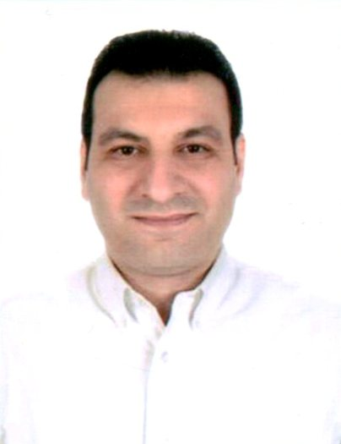
NIDAL

NIDAL.366815@2freemail.com

Curriculum Vitae
Apply For Pubic Relation Officer (PRO)
PROFILE

I am highly motivated individual with a keen eye for detail. I am looking for an opportunity to prove my worth and advance my career as far as possible. I consider myself to be an effective team player with excellent work skills.

I believe given a chance I would become an asset to my company immediately.

CAREER EXPERIENCE

- Working as PRO in Galadari Group, Dubai – U.A.E (Oct 2015 to till date).
Duties & Responsibilities:
  - Organize periodic renewal of Licenses
  - Submission of correct documentation to the Ministry Of Labor for visa applications & immigration.
  - Submission of correct documentation to obtain licenses and efficient collection of Licenses to take place when completed
  - Take, submit & collect all necessary documentation in order to organize all Employee official paperwork.
  - Arrange medical tests, passports, memos, promotional draws and fine resolution.
  - Represent the Company at locations such as the Police Station, Airport, Hotels, Embassies, Ministries/Municipalities & other significant Departments & in accordance with services such as mobile & landline phone services
  - Accompany the employee as they exit the country.

- Worked as PRO & Operation Officer in Rukun Aljawdah Plastering & Tile Cont ,
Sharjah – U.A.E (Mar 2013 to Sep 2015).
Duties & Responsibilities:
- Deal promptly and productively on general enquiries about PRO functions
- Assist the office in determining any issues identified with organization vehicle registration and renewals
- Acquire visas from different Embassies in UAE for staff members for business related travels
- Knowledgeable enough on the process of getting residency permits etc.

- Worked as Operation & PRO in Servo Transport L.L.C , Ajman – U.A.E
(Feb 2007 to 2013).
Duties & Responsibilities:
- Develop a marketing communications plan including strategy, goals, budget and tactics
- Develop media relations strategy, seeking high-level placements in print, broadcast and online media
- Coordinate all public relations activities
- Direct social media team to engage audiences across traditional and new media
- Leverage existing media relationships and cultivate new contacts within business and industry media
- Manage media inquiries and interview requests

- Worked as PRO in Al Qariya TV, Dubai Media City – U.A.E (Jan 2006 to Jan 2007).
Duties & Responsibilities:
- Experienced in visa and other transactions, knowledge of DUBAI and UAE Labor Law.
- Well-developed skills in written and spoken English & Arabic.
- Able to work under pressure to demanding time pressures and to meet deadlines.
- High level of professionalism and personal presentation at all times

- Worked as PRO in Al Dyar Used Car, Dubai– U.A.E (Sep 2003 to Dec 2005).
Duties & Responsibilities:
- Monitor, analyze and communicate PR results on a quarterly basis
- Evaluate opportunities for partnerships, sponsorships and advertising on an on-going basis.
- Build relationships with thought leaders to grow industry awareness
- Maintain a keen understanding of industry trends affecting clients and make appropriate recommendations regarding communication strategy surrounding them

- Worked as PRO in Al Jazy Travel & Tourism, Jordan (May 1995 to June 2003).
Duties & Responsibilities:
- Manage media relations and requests
- Write press releases, speeches and other PR copy
- Plan and supervise events, fairs, conferences etc.
- Support the implementation of promotional plans
- Present solutions in times of PR crisis
- Facilitate the resolution of disputes with the public or external vendors
- Lead survey initiatives and analyze public opinion

PERSONAL INFORMATION

- Language : Arabic and English
- Nationality : Jordanian
- Date of birth : 30/05/1976
- Place of birth : Jordan
- Marital status : Single
- Visa status : Employment visa (Dubai)
- License : Dubai Valid Driving License

EDUCATION

- High School Education With Scholastic Records
- Complete Documents Production Course (Galileo)
- Complete Comprehensive Course Concerning MS Office Application , Arabic World institute in Amman (Graduated with Excellent Scholastic Record)

CAREER OBJECTIVE

- A mid-level position with an opportunity for growth and advancement within the scope of my studies or other related fields.

SKILLS AND ABILITIES

- Have a good experience in public Relation Officer (PRO).
- Have a good Relationship in Embassies, immigration, Ministry Of Labor, Ministry Of Law And All Gov Departments.
- Excellent ability to work under pressure.
- Excellent computer knowledge.
- High problem solving ability.
- Work very well independently or with a team.
- Self motivation.
- Study desire.

REFERENCES

Available upon request.

