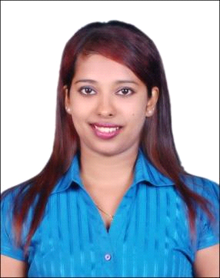CURRICULUM VITAE
Shiny
Shiny.366827@2freemail.com

Career Objective
To seek a challenging and interesting job that encourages creativity and provides exposure to new technologies to achieve professional and personal growth along with the organization.

Professional Experience

Ourshopee Co. Dubai - Working as receptionist from October 2015 to February 2017
- Dealing with calls in a highly professional manner.
- Handling complaints in an efficient and diplomatic way.
- Accurately updating customer records with information.
- Quickly understanding a callers point of view and to empathize with them.
- Able to respond and adapt to the needs of all customers and queries.
- Fully aware of all laws & regulations regarding data protection.
- Quickly processing information.

Arrow Showroom, Mangalore - Worked as a Customer service representative and Cashier - July 2014 to November 2014
- Receive payment by cash, check, credit cards, vouchers, or automatic debits.
- Issue receipts, refunds, credits, or change due to customers.
- Count money in cash drawers at the beginning of shifts to ensure that amounts are correct and that there is adequate change.
- Greet customers entering establishments.
- Maintain clean and orderly checkout areas.
- Establish or identify prices of goods, services or admission, and tabulate bills using calculators, cash registers, or optical price scanners.

Fastrack Showroom, Mangalore - Worked as a Customer service representative and Cashier - Aug 2013 to April 2014
- Greeting the customers entering into showroom
- Handling all the cash transaction of showroom and maintaining daily cash accounts
- Receive payment by cash, cheque, and credit card.
- Maintain clean and orderly checkout areas.
- Guiding and solving queries of customer.

Mphasis at HP Co. Mangalore - Worked as a KNE, Call center Assistant- May 2012 to Mar 2013
- Determines requirements by working with customers.
- Answers inquiries by clarifying desired information; researching, locating, and providing information.
- Resolves problems by clarifying issues; researching and exploring answers and alternative solutions; implementing solutions; escalating unresolved problems.
- Sells additional services by recognizing opportunities to up-sell accounts; explaining new features.
- Maintains call center database by entering information.
- Keeps equipment operational by following established procedures.

Strength:
- Strong organizational, administrative and analytical skills.
- Ability to multi task and manage conflicting demands.
- Sincere and hard working with a high level of integrity.
- Ability to work independently and under occasional stressful conditions while meeting deadlines.

Educational Qualification:
Examination | Board/University | College/Institution | Year of Passing
PUC | Mangalore University | Crossland college | 2006-2008
Airport ground staff, First Aid | Mangalore university | Frankfin Air Hostess training | 2012

Computer Skills
Tally, Galileo, MS outlook, Microsoft Office, MS Power Point,

Personal Details
- Date of Birth 23rd Sep 1990
- Nationality Indian
- Visa Status Visit Visa
- Languages English, Hindi, Kannada, Konkani

Reference – To be advised on request
I hereby declare that the particulars given above are true to the best of my knowledge and belief.

