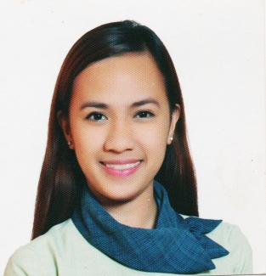

Personal Profile:

Name: MA. DIEVA

DIEVA.366838@2freemail.com

Objective:

To work in a company that would render the best of my skills and further enhance my ability propagation with the company's core objectives.

Skills Profile:

- Proficient in Microsoft Office (Word, Excel and PowerPoint).
- Flexible and able to handle multi-task work.
- Clerical works such as Sorting, Filing and Encoding.
- Knowledgeable in office orders and procedures.
- Creative, Dedicated, and Hardworking person.
- Cooperative in a team environment and can work independently.

Work History:

Bright Head Tutorial Center, (Tutor Teacher) , June 15, 2016 up to April 10, 2017

- Teaching all subjects in Primary level.
- Helping student in making their projects and homework.

Saint Paul Educational Center, (Teacher Adviser) , June 05, 2013 up to March 31, 2016

- Teaching Primary level of students for 3 years. Handling Math, Science, and Computer.
- Keep all the student records.

National Irrigation Administration (NIA) Construction Management Division, Internship Program (Office Clerk) , April to May 2012

- Operate office machines, such as photocopiers, scanners, E-mail systems and personal computers.
- Process and prepare documents such as business and government forms.
- Type, format and edit other documents using computers and typewriters.

Demo Power , Internship Program (Product Ambassador of Nestle Ice Cream) , April - May 2011

- Represents a brand to targeted customers and in order to generate sales opportunities.

- Creates attention and sales leads.

Pag-Ibig Fund Kamias Branch, MC Accounting Division, (On the Job Training) , Nov. ‘2010 up to March ‘2011

- Compile, copy, sort and file records of office activities, business transactions and other activities.
- Review files, records and other documents to obtain information.
- Answer telephones, direct calls and take messages.

Education and Trainings:

Polytechnic University of the Philippines
Degree Course: Bachelor in Business Teacher Education (BBTE)
Major in Business Technology/ Technology and Livelihood Education
S.Y 2009-2013

Ramon Magsaysay (Cubao) High School
Ermin Garcia St. Cor. EdsaCubao Q.C
S.Y. 2005-2009

“#QUESCIE@itsbest: A Revisit Professional Growth Program towards Educational Reforms”
Quezon City Science High School , June 6 to 8, 2016 ( 3 days seminar )

Eligibility: PRC – Licensure Examination for Teachers ( LET )
Board Passer – March 20, 2016

References:

(Available upon request.)

I hereby certify that the above information is true and correct to the best of knowledge and belief.

