To Whom It May Concern

This letter and the enclosed CV shows the impression of my interests in seeking a challenging position in a positive environment to proceed and grow with the organization. Make an effort to build trust in me as an asset for the accomplishment of organizational goals.
I believe that my capabilities would be an asset for your organization, and would deeply appreciate the opportunity to work with you and to make you proud that how my skills and background might fit in with your current and future needs.
Thank you in advance for your time and consideration & I am looking forward to your reply.

CURRICULAM VITAE |  |  |  | 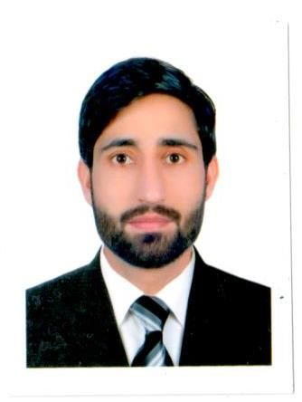  Sheikh  Sheikh.366861@2freemail.com |  |  | 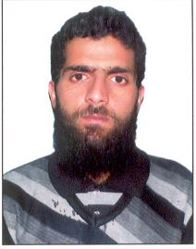
Locations of Interest |  |  | UAE
Professional Experience |  |  | 3+ Years
Career Objectives |  |  | I Intend to build a career with leading reputed company with committed and dedicated Staff, which will help me to explore myself fully and realize my potential. Willing to work as a key player in challenging environment.
Field & Position of Interest |  |  | Overseas Reputed company, Any assignment related to my field which will surely support to the organization and for the betterment of society by virtue of my profession & remarkable knowledge. I am ready to work on any challengeable & responsible position according to my field.
Summary |  |  | Quick learner, efficient, reliable and dedicated professional with more than 03 years of experience in CORPOATE at different positions, who believes in practicality rather than in credentials, works well under pressure with minimum supervision.
Work Experiences
1st October 2016 Till present
Merchandiser in EURO STAR COMMUNICATION LLC.

Job Responsibilities:

- Plan and develop merchandising strategies that balance customers’ expectations and company’s objectives.
- Analyze sales figures, customers reactions and market trends to anticipate product needs and plan product ranges/stock.
- Collaborate with buyers, suppliers, distributors and analysts to negotiate prices, quantities and time-scales.
- Maximize customer interest and sales levels by displaying products appropriately.
- Produce layout plans for stores and maintain store shelves and inventory.
- Forecast profits/sales and plan budgets.
- Monitor stock movement and consider markdowns, promotions, price changes, clear outs etc.
- Build constructive customer relationships and team with channel partners to build pipeline and close deals.
- Remain up to date with industry’s best practices.

27th July 2014 – 23rd August 2016 Floor Sales Executive @ NESTO Hypermarket store located in Sharjah Dubai.

Job Responsibilities:

- Listening to customer requirements and presenting appropriately to make a sale.
- Make sure pricing is correct.
- Ensure products are clean and ready to be displayed.
- Maintain inventory and ensure items are in stock.
- Ensure promotions are accurate and in tune with company’s standards.
- Read daily, weekly, monthly sales reports.
- Maintaining and developing relationships with existing customers in person and via telephone calls and emails.
- Negotiating the terms of an agreement and closing sales.
- Monitor local competitors.
- Maintain health and safety measures and store’s cleanliness
- Reviewing your own sales performance, aiming to meet or exceed targets.
- Attending team meetings and sharing best practice with colleagues.
- Handle customer complaints, issues and questions.
- Challenging any objections with a view to getting the customer to buy.
- Advising on forthcoming product developments and discussing special promotions.

1st March 2012 – 30th April 2013
Ground Staff at INDRA GANDHI INTERNATIONAL AIRPORT NEW DELHI INDIA.
Seminar Attended |  |  | Various Seminars attended at IIET JAMMU on Social and Moral upliftment. Attended personality development seminars organized on university level.
Extracurricular  Activities |  |  | Participated in Annual Functions organized by IIET JAMMU.
Technical Qualifications |  |  | Basic Computer Application & Tally.
Educational Qualifications |  |  | Diploma through IIET in the year 2011 and secured 89%.
 |  |  | 12th through J&K State Board of School Education in the year 2010 within 1st division & proceeded for IIET.
Personal Information
DISTRICT & CITY |  |  |  |  |  | Deira
STATE |  |  |  |  |  | Dubai
COUNTRY |  |  |  |  |  | UAE
PIN CODE
NEAREST POLICE STATION |  |  |  |  |  | Naif
NATIONALITY |  |  |  |  |  | Indian
RELIGION |  |  |  |  |  | Islam
D.O.B |  |  |  |  |  | 03/02/1991
SEX |  |  |  |  |  | Male
MARITAL STATUS |  |  |  |  |  | Single
identification mark |  |  |  |  |  | Mole on Chest
HEIGHT |  |  |  |  |  | 5.8 Inches
BLOOD GROUP |  |  |  |  |  | A Positive
LANGUAGES | Read, Write & Speak |  |  |  |  | Kashmiri, Urdu & English
LANGUAGES | read Only & Speak Poor |  |  |  |  | Arabic
HOBBIES |  |  |  |  |  | Travelling, Reading & Social Activities

