Eslam
Eslam.366873@2freemail.com
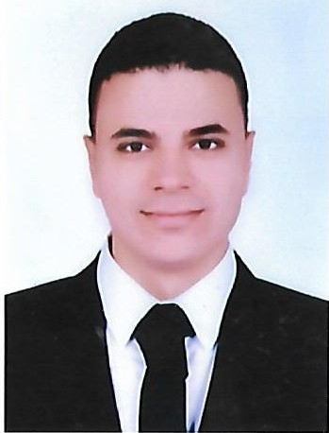
Job objectives

To obtain a challenging position in a well repeatable organization that will allow for growth & development and a chance to use and contribute my education, knowledge, and special skills.
Personal Data

- Gender : male.
- Marital status : Single.
- Date of Birth : 15 March 1992 .
- Military service : Exempted .
- Nationality : Egyptian
- Add : UAE

Academic Qualification

- Graduate :Bachelor's degree in faculty of commerce ( accounting) .
- Grade : Good .
- University : Bani Suief University ( May 2014 ) .

Employment ( My work experience)

- Accountant in Hotel ( Sultan gardens ) for 9 months .
- Accountant in Hotel ( Stella de mari ) for 6 months .

Tranining Courses

- ICDL
- Human Development
- Electronic Accounting (training on a program beach trey & excel )
- English courses
- A certificate from the International Centre for Accounting

Languages

- Arabic : Mother tongue .
- English : Very good (understanding & speaking) .

Objective
- Seeking a challenging position that enable me utilize my skills and fulfils
my strong ambition for success.
Personal Skills

      - Ability to work in a group according to the job requirement
      - Able to learn new technologies
      - Hard worker and can work under stress
      - Problem handler and know how to deal with different situations
      - Good communication skills
      - Customer interaction
      - Relation building
      - Attention to details and very well organized

