VIKESH
VIKESH.366880@2freemail.com

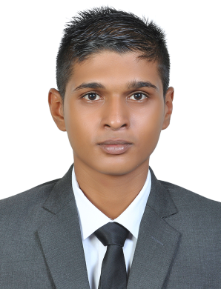

Profile Statement:

A hardworking and multitasking professional seeking to achieve apex of success in the field of
Hospitality & travel industry with qualities like adaptability, honesty and integrity.

PROFESSIONAL EXPERIENCE
- Received training and development for Customer Service Assistance.
- Traineeship completed as Hospitality Industry

EDUCATION

January 2012-November 2014: Forest Side SSS Boys (Mauritius)
- School Certificate- O levels: English, Sociology, Literature in English, Economics, French, Mathematics, Principles of Accounts, Business Studies
April 2016-September 2016: Projet Employabilite Jeunes (Youth Employability Project, PEJ)
- Trained for workplace realities through training in the social and academic skills required for a rewarding personal and work life as well as work placements, mainly in Beachcomber hotels.
- PEJ trainees received training leading to a vocational qualification in hotel techniques along with work placements, which allows them to return to education through continuous learning.

WORK EXPERIENCE

April 2016- September 2016: Waiter at Shandrani Resort and Spa (Mauritius)
- Take guests orders.
- Serve foods and beverages
- Present menus to guests and answer questions about menu items, making recommendations upon request.
- Clean tables or counters after guests have finished dining.
- Prepare hot, cold, and mixed drinks for patrons, and chill bottles of wine.
- Inform customers of daily specials.
- Remove dishes and glasses from tables or counters; take them to kitchen for cleaning.
- Escort customers to their tables.
- Provide guests with information about local areas, including giving directions.

January 2015 – October 2015: Receptionist at Heritage le Telfair Golf and Spa Resort (Mauritius)
Heritage le Telfair Golf and Spa Resort is an elegant hotel set in the tropical gardens in the south east coast of Mauritius. My main responsibilities as a receptionist were:
Provide support services in order to ensure efficiency and effectiveness within the
great organization.
As a hotel receptionist, my main duties included:
- Dealing with bookings by phone, e-mail, letter, fax or face-to-face.
- Completing procedures when guests arrive and leave.
- Choosing rooms and handing out keys.
- Preparing bills and taking payments.
- Taking and passing on messages to guests.
- dealing with special requests from guests (like booking theatre tickets or storing valuable items)
- Answering questions about what the hotel offers and the surrounding area.
- Dealing with complaints or problems.

SKILLS
Computing:
- During my course, I have acquired a whole range of IT skills, many self-taught. My present bank of skills includes: Microsoft Word, Microsoft Excel and Microsoft PowerPoint.
Team work:
- Group work is an integral part of my job and of my past work experiences. The high quality of the work produced by my group has been dependent on our ability to work well together as a team.
Communication:
- Gained good communication skills during my past work experiences from giving presentations and participating in group work. Communicated clearly and persuasively both orally and in writing, expressed own viewpoint coherently and succinctly. Fluent in both English and French.

