CURRICULUM VITAE
ABIOLA
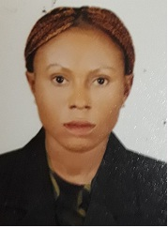
ABIOLA.366888@2freemail.com

OBJECTIVE
To obtain a challenging position with supportive environment to allow full use of my education, experience talent, initiative and communication skills to further benefit to the institutions productivity and to increase opportunities and for personal advancement.
EDUCATION QUALIFICATION
- First School Leaving Certificate.
- Senior Secondary Certificate Examination
- National Diploma

WORK EXPERIENCE
- Worked as a Waitress at Twins base hotel , Nigeria.
- Worked as a Waitress at Al jubril Hotel and suit dubal , UAE.
Skills and Competencies:
- Good interpersonal and communication skills.
- Strongly believe in teamwork.
- Having suitable fitness level.
- Ability to work for long hours under pressure

PERSONAL INFORMATION
Date of Birth :08-08-1986
Sex :Female
Nationality : Nigerian
Religion : Christian
Marital Status :Single
Language Known : English

DECLARATION:
I hereby declare that the above mentioned details are true and correct to the best of my knowledge

