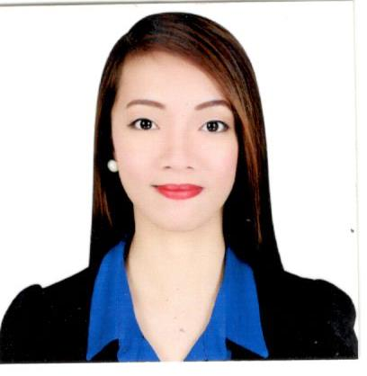
SARAH G. LIWANAG

SARAH
SARAH.366927@2freemail.com
#5 Romasanta St. Brgy. Purok Pagmamahal. Wescom Rd. Brgy. San Pedro, Puerto Princesa City
Contact #: 09757707112/09076587687
E-mail Address: sarahliwanag.21@gmail.com

QUALIFICATIONS:

- Graduate in Bachelor of Science in Information Technology
- Experience as an Encoder
- Experience as a Cashier
- Fluent in English and Filipino
- Excellent in Microsoft application, computer application installation, computer formatting and network trouble shooting.

EDUCATIONAL BACKGROUND:

Bachelor of Science in Information Technology
Palawan State University
Attended: 2011-2015
Awards received: Dean’s Merit Award (Academic Proficiency) 1st and 2nd Semester, SY: 2012-2013

Secondary Education
Puerto Princesa City National Science High School
Attended: 2007-2011
Award received: Loyalty Award

WORK EXPERIENCE:

Staff / Encoder
Day Care Service Program Office
New City Hall, City Government of Puerto Princesa
July 8, 2015-December 31, 2015
- Arranges the entry of data into excel
- Documents all the activities and programs of the department
- Organizes the schedule and itinerary of the teachers
- Write minutes of the meeting
- Encoding attendance
- Encoding letter transactions

Branch Cashier
St. Peter Life Plan Inc.
June 6, 2016-Dec 6, 2016
- Assistant to the Branch Manager
- Prepares transmittal (vouchers, loans, reinstatements, bank checks)
- Prepares bank deposits
- Conducts sales and presentation to potential clients
- Handles all cash transactions of the branch
- Submit and reconcile office reports
- Act as the point of contact for internal and external clients

TRAINING AND SEMINARS ATTENDED:
Gender and Health Summit
Dolcevita
Puerto Princesa City, Palawan
April 04, 2014

Job-fair seminar
SkyLight Convention Center
Puerto Princesa City, Palawan
Feb 18, 2015

Introduction to Android Development and Robotics
UP IT Development Center
Diliman, Quezon City
March 4, 2015

Apple in Education and Network Security
UP IT Development Center
Diliman, Quezon City
March 4, 2015
Slingshot Your Career in IT Networking
Dynamic Technology Education IT Training Center
Ortigas Center, Pasig City
March 5, 2015

PERSONAL INFORMATION:

Gender : Female
Age : 22
Date of Birth : September 21, 1994
Civil Status : Single
Citizenship : Filipino
Height : 5’2

I hereby certify that the above information are true and correct to the best of my knowledge and belief.

______________________
(Signature)

