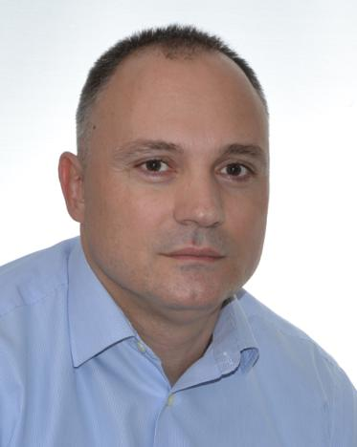
Vladimir
Vladimir.366937@2freemail.com

Veterinary Doctor

SUMMARY

Key professional goals - The main professional goal I strive and will continue to strive towards is to become a valued member of a highly organised team of veterinarians I could share the wide scope of knowledge and expertise I posses, as well as to fill in any potential gaps I may have through teamwork and cooperation. My desire is not to become a mere cog in a well-oiled impersonal machinery, but to find a workplace environment resembling a close-knit family I would be proud and happy to become a part of.

PROFESSIONAL EXPERIENCE

Part-time Veterinary doctor

PRIMAVET Veterinary clinic Kraljevo, Serbia (2015-present)

- Diagnosing and treating companion animals for various medical conditions

- Performing routine surgical procedures:
  - Soft tissue surgery: De-sexing, intestine FB removal, cystotomy, hernias;
  - Eye surgery: Simple palpebral correction, eye wound treatment
  - Skin surgery: Mass removal, aural haematoma and wound management, as well as dental procedures (dental scaling and polishing, tooth removal)
- Operating medical equipment: X-ray and ultrasound, as well as interpreting the resulting images
- Running blood/urine/fecal tests
- Microchipping and vaccination
- Prescribing medications
- Working with animal drugs and food
- Advising animal owners on general care, medical condition and treatment
- Educating handlers and trainers about diseases that can be transmitted from animals to humans
- Advising handlers about sanitary, feeding and general care necessary to improve the health of animals

Veterinary surgeon

Dog and Cat shelter - JKP CISTOCA Kraljevo, Serbia (2012-present)

- Triage of dogs and cats entering a shelter, behavioural evaluation, microchipping, deworming and vaccination

- Internal medicine diagnostics and treatment
- Skin disorder diagnostics and treatment
- Performing common surgery: ovariohisterectomy, neutering, intestine FB removals, cystotomy, umbilical and inguinal hernia, skin surgery (mass removal, aural haematoma and wound management)
- Collecting body tissue, feces, blood, urine and other bodily fluids for examination and analysis
- Carrying out blood tests using haematology analyser
- Operating x-ray and ultrasound equipment and interpreting the resulting images
- Advising animal owners on general care, medical condition and treatment
- Animal euthanasia

page 1 of 2

Veterinarian

PRIMAVET Veterinary clinic Kraljevo, Serbia (2008-2012)

- Internal medicine diagnostics and treatment

- Routine soft tissue surgery: de-sexing and wound management
- Working with animal drugs and food
- Microchipping and vaccination
- Advising animal owners on general care, medical condition and treatment
- Educating handlers and trainers about diseases that can be transmitted from animals to humans
- Advising handlers about sanitary, feeding and general care necessary to improve the health of animals

Associate Veterinarian

MEDIVET Veterinary station Kraljevo, Serbia (2005-2008)

- Farm and small animal practice

- Preventive treatment, nutrition, housing and breeding advice
- Internal medicine diagnostics and therapeutic treatment
- Surgical procedures with emphasis on soft tissue surgery

EDUCATION

University of Belgrade, Serbia

Faculty of Veterinary Medicine, 1993 - 2004
Veterinarian (Licenced Doctor of veterinary medicine)

Veterinary Collegiate "Dr. Djordje Radic" ,Kraljevo, Serbia

High School, Pre-Veterinary Studies, 1989 - 1993
Veterinary Technician

TECHNICAL PROFICIENCY & SKILLS

Computers skills:

- MS Office advanced level (Word, Excel, Access, Powerpoint, Outlook)

LANGUAGES

English: Full professional proficiency

Serbian: Native or bilingual proficiency

KEY STRENGTHS

- Responsible

- Caring

- Reliable
- Good teamworking skills

- Strong work ethic

- Communication skills

- Interpersonal skills

page 2 of 2

