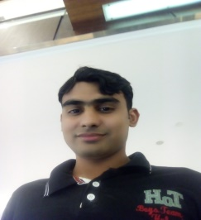 SAJID
EXPERIENCES
- Designation: Office boy
  - Organization: DBBG
  - Jobs nature: Civil Store keeper.
  - Duration: 2 year
  - Location: UAE Dubai

  - Designation: Computer operator
  - Organization: Motorway toll plaza
  - Duration: 1 Year
  - 2 year experience as a housekeeper in Taj Mahal hotel & restaurant, in Nowshira pakistan.
SKILLS
It skills
- MS Office (Word, Access, Excel, PowerPoint)
- Typing 30wpm

Signature.
SAJID.366952@2freemail.com
About me
I am a young energetic male honest, and self-motivated person, hard working with positive attitude towards my career and life.
CAREER OBJECTIVES
“To be a part of a dynamic team, where I could exercise all those skills taught to me in entire education period and to exercise my skills and knowledge by joining a progressive organization where job tasks are challenging and opportunities are available.”
EDUCATIONAL VITALITY
- Graduation: Bachelor year of passing (2013)
Abdul Wali Khan University of mardan Khyber pakhton khowa Pakistan
Division: 3st division
Marks: 274 cgpa out of 4
Percentage: 50%
- Intermediate: pre-computer since year of passing (2011)
Board: BISE mardan kpk Pakistan
Institution: khoshal khan degree collage akora khatak, Jahangira, Pakistan
Division: 3st division
Marks: 501 out of 1050
Percentage: 47%
- Matriculation: science year of passing(2008)
Board: BISE mardan kpk Pakistan
Institution: Govt high school misri banda akora khattak kpk Pakistan
Division: 3st division
Marks: 479 out of 900
Percentage: 53%
Languages Pashto, Hindi, English,

