CURRICULUM VITAE
Ahereza
Ahereza.366959@2freemail.com 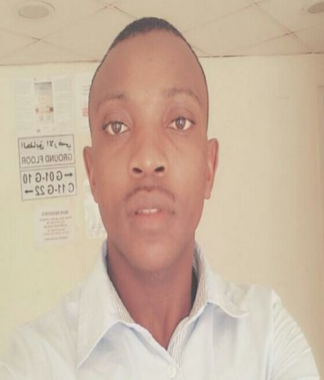
DESIRED JOB: WAITER
EDUCATION BACK GROUND
INSTITUTION | PERIOD | QUALIFICATION
Makerere University | 2012-2015 | Bachelor of Tourism and hospitality
Buremba sec School | 2005-2011 | A-level Certificate
Kakoni Primary School | 1999-2004 | Primary certificate

WORK EXPERIENCE
- Waiter Tamween Hospitality LLC up to date
- Waiter Grand Global hotel Kampala Uganda 2012-2013
- Waiter Imperial Royale Kampala Uganda 2014-2015
DUTIES
- Welcoming guests, Taking guest orders
- Assisting guests to the seats, Serving the orders,
- Arranging and Cleaning tables

COMPETENCES AND SKILLS
- Excellent communication Skills
- Computer literacy in spss program
- Aggressive hospitality,
- Customer service and itinerary development,
- Creative and innovative.
LANGUAGE PROFICIENCY
Language | Spoken | Written
English | Very good | Very Good
Kiswahili | Very good | Very Good

HOBBIES
- Playing foot ball
- Watching wild life documentaries
- Visiting the internet
- Creating friends
CAREER VISION
Working for the betterment and success of the company through promotion of equal opportunities and creating enabling environment for fair competition and equal rights of all mankind while cooperating with others through team work and peaceful environment, the growth of individual careers and realization of organization goals and objectives

