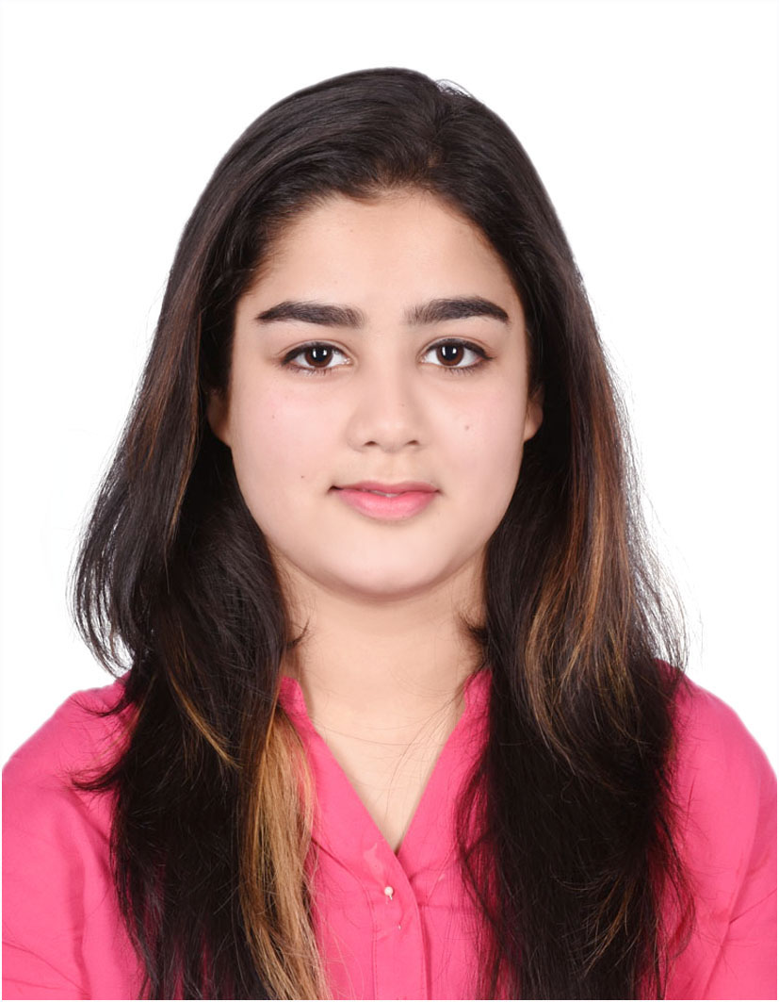

CURRICULAM VITAE

MAVIYA
MAVIYA.366972@2freemail.com

Career objective

To secure a challenging career with Dynamic, Servicing, Progressive organization in order to utilize my abilities, knowledge and personal acumen with integrity contribute in the development.
Education Qualification

HSC / 2016
- St. Michael’s School – Bhopal, India
- High School Diploma, 2014 with 72%
- Higher Secondary Diploma in Computer Commerce, 2016 with 65%
Computer Qualification

- Computer Operating
- MS office
- Internet.(Emailing, Browsing, Chatting etc…).

Strength

- Self confidence
- Good leadership qualities and team spirit
- Organizing skills
- Communication skills and convincing power other information

Work Experience

- Worked as an Electronics Sales Associates in MANGALAM ELECTRONICS L.L.C, Bhopal (2014-2015)
Duties and Responsibilities
- Selling all kinds of Brand Mobiles.
- Achieved monthly sale closing goals on a consistent basis.
- Responsible for all sales and customer service issues in the mobile sales department.
- Look after all mobile devices and keep them in a good condition
- Identify customer needs on sale Flore and recommend appropriate solution
- Helped customers with all electronic related needs.
- Help keep daily achieving daily sales targets and maintain sales report.
- Maintained a clean and organized work environment to allow customers the best shopping experience.

- Worked as an Sales Associates in PANTALOONS L.L.C, Bhopal (2015-2016)
Duties and Responsibilities
- Handle tasks of getting clothes for trial
- Responsible for providing knowledge of fabrics and materials to customers.
- Handle tasks of preparing and maintaining sales record on a daily basis.
- Participate in sales training and programs to enhance sales skills and techniques.
- Ensured to generate an atmosphere of hospitality and flexibility with the guests.
- Resolved customer inquiries and conflicts.
- Responsible for responding to customer queries and update upcoming clothing to customers.
- Responsible for responding to customer queries and update latest upcoming dress to customers.

Personal Information

Personal Information
Date of Birth : 27/12/1997
Marital Status : Single
Nationality : Indian
Languages Known : English, Urdu, and Hindi

Declaration
I hereby declare that the details furnished above are true and correct to the best of my knowledge and belief.

