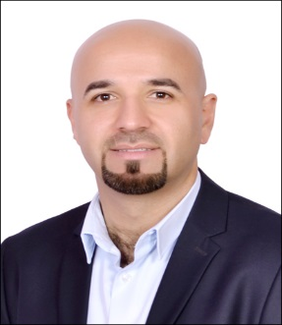 C.V

HAZIM
HAZIM.366988@2freemail.com

Personal Information
Date of Birth: | 11-08-1983
Place of Birth : | Irbid– Jordan
Nationality : | Jordanian
Education
- Bachelor Degree in Marketing – Faculty of Financial and Management Sciences – Petra University 2013.

OBJECTIVES
- Looking forward a Senior Sales Executive or Team Leader or Supervisor position, I want to succeed in a stimulating and challenging environment, building the success of the company while I experience advancement opportunities.
Professional Experience Record
- ALSHAYA ENTERPRISES
Jul 2016 – Present – ABU DHABI – UAE
Sales Executive (Projects)
In Alshaya Trading we supply the best brands of the ceramics tile & Sanitary ware from some of the best companies in Europe.

I used to follow up the new projects to propose our products, also I love to make a good friendship with the consultants and contractors, because that will help for any future project.
I have a good data about most of the companies in Abu Dhabi.

- RAK CERAMICS ( KLUDI RAK )
May 2015 to Jun 2016
Sales Executive
* Follow up the Project of Buildings & Villas.
* Propose the products of the tiles & Sanitary ware
* Convince the customers to select the models and purchase from us.
* Good knowledge about the technical specifications of the tiles of Ceramics & Gress Porcelanato.

- MACMILLAN Distribution & Publishing (Jarir)
Sales Executive
From Sep 2013- to Apr 2015
- Bristol –Amman, Employee in Receptionist
From June-2009 to March 2012
- Four Seasons – Amman, Employee in Spa and Gym Club
From January-2005 to January 2008

Skills
- Strong presentation skills.
- A passion for selling.
- Strong negotiation skills.
- Good time management.
- Ability to communicate with people at all levels.

- A high degree of self-motivation.
- Participant in Several Book Exhibitions in (TESOL Arabia, Sharjah, Qatar, Kuwait, Bahrain and Oman).
- Working Under Pressure as One Team.
- Good Experience for Schools and Universities Methods.
- Good Experience for a SAP Program.
- Good Experience for Al Ameen Program.
- Have a Good Experience for Arranging Books and Courses.

Languages
- Arabic: Excellent, Mother language.
- English: Good (Listening, Reading, Speaking and Writing)

Others
- UAE Drive License

