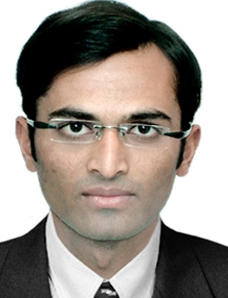
ANIL
ANIL.366989@2freemail.com

Target Job
Pharmacist
Career Level: Mid Level
Target Job Location: UAE
Career Objective: My career goal is to explore challenging opportunities that would not only allow me to enhance my analytical and technical abilities but also allow me to contribute to the development of the organization
Employment Type: Full Time Employee
Notice Period: IMMEDIATELY

EXPERIENCE
June 2015 –Apr-2017
Pharmacist at Life Healthcare Group
Location: Dubai, United Arab Emirates
Job Role:
1. Dispensing medicine
2. Insurance Confirming Rx, and ins card details, Taking approval from various portal
3. Handing controlled medicine Rx Verifying Authenticity of Rx and valid I'd proof Maintaining controlled medicines register.
4. Promoting supplement

November 2014To May 2015

Pharmacist at PRIMARY HEALTHCARE CENTER
Location: Rajkot, India

1. Dispensing medicine
2. Maintaining Patients record
3. Maintaining Diseases record

September 2012 - October 2014
Pharmacist at LALA CHEMIST
Location: Rajkot, India
Job Role: Medical, Healthcare
1. Dispensing Medicines
2. Selling OTC medicines

July 2011 - August 2012
Life Executive at RANBAXY LAB LTD
Location: Rajkot, India
Job Role: Sales

EDUCATION
Bachelor's degree,
Pharmacy at Saurashtra University
Location: Rajkot, India
Completion Date : April 2010
Grade: 56.14 out of 100

High school, 12th
at Vivekanand vinay mandir
Location: Rajkot, India
Completion Date: April 2006
Grade: 69.40 out of 100
11-12 th science

SKILLS
COUNSELING : Expert
MS OFFICE : Expert
Microsoft AX Dynamics : Expert
POS : Expert
Soft Skills : Expert

LANGUAGES
English Level: (Expert)
HindiLevel: (Expert)
GujaratiLevel: (Expert)
UrduLevel: (Speaking)

PERSONAL INFORMATION
Birth Date: 16 March 1989 (Age: 28)
Gender: Male
Marital Status: Married
Nationality: India
Residence Country: Dubai, United Arab Emirates

I hereby declare that the above-mentioned information is true to the best of my knowledge.

