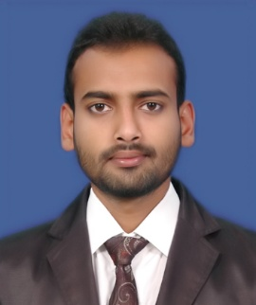 SHAIK

SHAIK.366991@2freemail.com

CAREER OBJECTIVE

To pursue a successful career in an organization that provides day to day challenges and in turn opportunities to grow.

EDUCATION DETAILS
Qualifications | Name of the institute | Year of passing
BBM | SDCIMS  Bangalore University | 2014
II PUC | SDC PU College Kolar | 2011
SSLC | Al-Ameen English High School Kolar | 2009

TECHNICAL SKILLS
Microsoft Office,
Microsoft Excel,
C++
Tally.ERP9,
JD Edwards,
Aurora,
Pronto.

Work profile

IBM:

- Designation : Accounts Executive in Payable’s
- Duration : From 1-AUG- 2014 to 20-MAR-2015
- Project : Telstra
- Role:

- Maintaining invoices indexing to processing and handling clients,
- Entering invoices, solving queries from start of task to end,
- Solving issues online for suppliers related to payments.

Greet Technology (Tally Solution):

- Designation : Accounts process Executive
- Duration : From 30-MAR- 2015 to 30-SEP-2016
- Department : Accounts dept

- Role:

- Maintaining Books of Accounts for the Day to Day Business Transactions in Tally ERP9 Software which effect on Trial Balance, P&L A/c, Balance Sheet, Receipts& Payments and Payroll.
- Manage Accounts Payable and Receivable
- Manage all taxation matters such as Income Tax, Service Tax, Excise, TDS, Vat etc. on regular basis.
- Handle reconciliation of all accounts including monthly Bank Reconciliation Statements.

CAPGEMINI:

- Designation : Process Associate
- Duration : From 09-JAN- 2017 to 30-APR-2017
- Department : Accounts Payable’s
- Project : Sandvik

- Role:
- Q2R in team payables for Australia and New Zeeland sandvik mining and constructions.
- Reconciling invoices and invoice statement’s of sandvik entities for payment to suppliers.
- Maintaining accounts in systematic manner for payment in erp software’s.

PERSONAL INFORMATION

Date of Birth : 21/09/1994
Marital Status : Single
Religious : Islam
Nationality : Indian
Languages : English, Hindi, Kannada & Urdu.
Hobbies : (Swimming, Playing Football,
Playing carom board, Making Good Friends, Reading Islamic Books).

Declaration:
I hereby declare that the above information is correct to the best of my knowledge.

