Divya
Divya.366992@2freemail.com
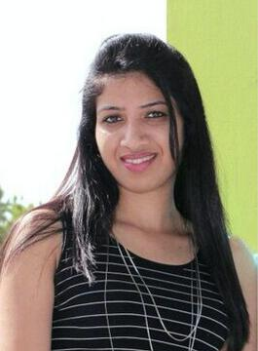

Pr ofe ssional S kills

Brand Mar keting

St rategy Planni ng

Socia l Me dia & D gitali (S EM, SEO & all gamut sof d gitali br and building) Event manag em ent & pla nning

Per so nal Tra its

Assert iv e, Team p ayerl, Gre at l ev el o f pat enci eto e xtra ct th eb est fr om a tea m at trying sit uatio ns. S ti ckler for dead li nes, enjoy smusic, cra fts & art and any o the r opp ortuni ty to rela x and be myself.

Educatio n

isan experienc ed adverti sing and mar keti ng pr ofe ssi onal, with over 9 ye ars of experien ce within the brand bu ilding space. Passionate about bran d buildi ng, wi th great eye f or detai l and proces s o rientation.

Wat ermel on Communicat ions, Dub ai

Sr. Ac count Mana ge r- New B usines s/ Clie ntServicing

Februa ry 20 12 - Pres ent | Re sponsib el for ne wbusiness gene ration a nd mar ket se edi ng, client serv ici ngo nse le ct bra nds lik eMal abar Gold, As te r D MHealt hcare, S pri ngd ales Schoo l etc. R ol e nvi ol ve sstra tegy p anningl fo r brands acros sall face ts of m arketi ng and m ark et sha re cre atio n. Me dia planni ngand implementat oi n, as w el l as new i nnovation/out-of-t he box disrup tive co mmunicati on pl ans.

K ey fo cus : Digital Mark et ngi, M ainline m edi ap lann ngi, Ma rketi ng S tr ateg y

S utra M agnus Adverti sing, Dub ai Acc ount Ma nag er - Cli ent S ervicing

Ma rch 2 011 - Jan 20 12 | Res po nsib le for client relations an dd ay to d ay br and m ana gem ent f or b ran ds like SONY, Sharp, Aste r DM H ealt hcare, L'Oreal Co sm et ics a nd Oman I nsur ance Co mp any.
Ke y focus : St rate gy pl anni ng, Visual Me rch andisi ng a nd dis pl ay

TB² WA - India, Bang alore
S r. Acc ount Exe cutive - Cli ent Se rvicing

Nov 2007 - Feb 20 1 - Pres ent | Re sponsib el to assi st the br and te am fo r all base resea rch wor k, br and impl em ent ati on app ro ach, reports, follo w-ups etc. Had t he pri vi egel of working wi th le adin ginter nation al bra nds ikl e App el Corp or atio n, TA TA(T anishq J ewelle ry, S par R eta il, Titan Eye ca re et c. Key focus : Ma rke t Re sea rch and pla nning, Imp le me ntation

B rands ex pos ed to duri ng my 9 year car eer

Post Gra duate in Bio-te chnology Pu rsui ng a P GDiplo ma in Soci al Med ia M ar ketin g an d SEM/S EO

