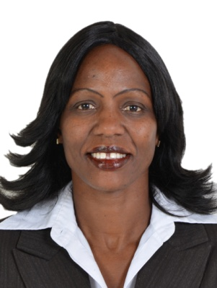
RESUME

CAROLINE
CAROLINE.366996@2freemail.com

Career Objective:

To be able to apply to the best innate wisdom, experience and theoretical skills I have acquired by working dynamically; and willing to work with a motivated team as a key player in challenging and creative environment.

Personal Profile:

Very organized-systematic, firm, principled with top notch customer care, and experienced in PR. Goal oriented, with a consistent track record of achieving the highest of standards in being articulate, eloquent and excellent communicator.

I embrace teamwork which enables business to run smoothly and makes each person feel part of the organizational achievement. Motivated to work with team spirited group for growth purposes.

Work Experience in different countries:
Worked at Kharafi National Company L.L.C.- Abu Dhabi, UAE from June 2014 - 20th May 2016
as In-charge of the Female Camp based in Al Ain

Duties:

- Reported directly to the Accommodation Unit Head
- Submitted daily, weekly and monthly reports to Accommodation Unit main office
- Coordinated activities to oversee proper standards of safety maintenance
- Made orders, maintain and account for proper inventory of supplies
- Supervises the staff working in the camp

Worked in Afghanistan USA & NATO Millitary (LOGCAP IV) from 2010-2013
I worked as Laundry and Billeting /Accommodation supervisor for DynCorp International

Duties:

- Managed the Master trucker
- Key Control responsibility
- Attended to customers’ complaints, investigated and resolved them
- Supervised crews at work, did inspections and ensured high standards of cleanliness
- Prepared the work schedule-duty roaster for both day and night shifts
- Prepared daily and fortnight reports to the Site Manager and FOB Mayor
- Answerable to the Manager

Actively involved in the Girl Child Empowerment (2005-2010) in Kenya
Giving back to society

Worked as PA to Dr. TJ Ocholla at The Dental X-ray Centre (1998-2005) in Kenya

- Over all In-charge of the facility, administration work and delegated duties to staff
- Attended trainings and rolled the information to employees by duplication form
- Arranged Inhouse meetings, attended corporate meetings, took minutes in meetings
- Represented my boss at meetings, replied to his mails - observed discretion
- Book keeping, maintaining the petty cash as well as handling purchases
- Managing Drs. Diary, arranged travel and booked patients for surgeries in hospitals

Academic Profile:

- University of Nairobi - Year 1994-1997 (Business Administration)

- Institute of Advanced Technology (IAT) - 1999-2000 (computer packages)
- Link training Institute (LTI) – 1992-1993 (Typing Elementary and Intermediate)
- Pansoms College January-March 1990 (Receptionist and Telephone Operator)

- Secondary School Certificate (KCSE) Ruaraka High School - 1986-1989

Work Aspects:

- High sense of professionalism
- Applies mandatory orientation to the new hires and In-service training wherever
- PR, Good customer care friendly yet very professional
- Good command of English grammar, efficiency in writing and in speech
- Co-ordinates activities to oversee proper standards of safety maintenance
- Arrange vacation and travel plans for employees
- Well conversant with administrative skills

Significant Reviews:

- Committed and Hardworking
- Interested in learning and development
- Philanthropic worker
- Other interests include reading, music and socializing with different kinds of people

Personal Details:

- Date of Birth : 9th May 1970
- Nationality : Kenyan
- Marital Status : Single
- Languages spoken : English, Kiswahili

