SELVAKUMARAN.367032@2freemail.com
With a sincere, dedicated hard work and dynamic cooperation and coordination where I can use my energy and skills to develop, motivate, lead and encourage employee productivity, improve operations and enhance growth  Name |  | SELVAKUMARAN
Date of Birth |  | 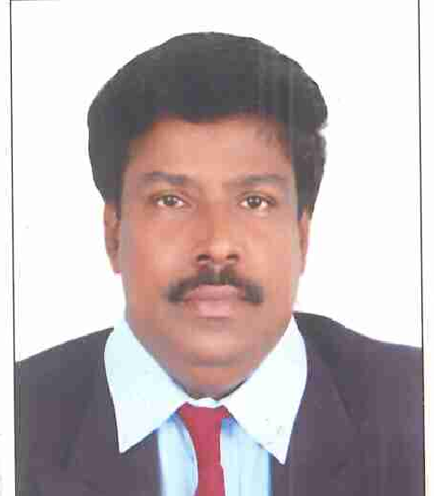  11th June 1967
Nationality |  | Indian
Gender & Martial Status |  | Masculine, Married

QUALIFICATIONS
 | ACADEMIC | B.Sc., University of Madras – 1988.
- Faith in ALMIGHTY, self-disciplined, Clean Habit, Honesty, Trust Worthy, Dedication, Sincerity, Proactive, well organised, Perseverance, Team Player, strong interpersonal skills & result oriented.  - 24 years’ experience – 13 years in Gulf (7 years in UAE; 6 years in Qatar, 1 Year in Seychelles)  - Handled complete admin and secretarial activities of Projects worth billions independently  - Proficiency in Business English, MS Office – professional Presentation  - Handled huge volume of pressure with ease and deliver goods in time  - Worked in Finance, Projects, Admin, Business Development, Marketing in depth  My strength | TECHNICAL | - Post Graduate Diploma in Computer Applications from Ministry of Industries, Government of India – MS Word, MS Excel, MS Access & MS PowerPoint etc
 |  | - Pitman Shorthand English – Intermediate – 100 Words Per Minute from Directorate of Government Technical Institution.
 |  | - Typewriting English – Higher Grade – 45 Words Per Minute from Directorate of Government Technical Institution.
 |  | - Underwent a training titled “Business English” at British Council, Doha and passed with Excellent Grade
 |  | - Other computer packages like Windows XP Professional 2000 & 2003, MS Word & Excel Access & Power Point, Lotus Notes & MS Outlook, ERP System for Contracts.
- ISO 9001 Documentation for contracts
- Time Management, Emotional Intelligence,
- Negotiation Skills, Interpersonal skills & Project Management

Job Description / Job Profile

Administration & Human Resources

- Provide High quality comprehensive administrative support and assistance to Senior Management, Functional Manager and associated function groups.
- Prepare required documents; time and expense reporting, coordinate travel, and arrange meetings, draft and edit letters, memos, invoices, meeting minutes, and other documents.
- Maintain calendar for the lead as well as direct reports. Accept/Decline meetings on the lead's behalf if tasked. Schedule meetings/book conference rooms.
- Prepare and maintain department Org Charts. Use Expedition to log transmittals, meeting minutes, internal memos, and letters sent to the client. Log incoming/ outgoing correspondence in Excel to allow accurate tracking of document flow. Gather information from contracts or other documents, and convert data into Word or Excel format and arrange formatting of information for use in reports. Maintain filing systems and control documentation.
- Maintain files of internal memos and other confidential internal correspondence for each manager.
- Provide backup support, as needed, and perform various administrative tasks as required.
- Proficiency in Microsoft Office Suite applications including Word, Excel, PowerPoint, and Outlook (calendar maintenance),
- Proven ability to communicate in person as well as via alternate methods (Web ex, conference call, etc.)
- Ability to handle multiple and routine tasks and work independently with little supervision.
- Recruitment, Job Analysis, Job Specification, Job Description, Performance Appraisal, MBO, KPI,

Finance & Insurance

- Accounts Receivable
- Accounts Payable as per International Accounting Standards.
- Bank Reconciliation and all banking entries & transactions.
- Reconciliation of Debtor & Creditor Statements & Age Analysis Reports
- Cash Flow Statement
- Balance Sheet, Income Statement, Financial Performance Report and works up to Trial Balance (Final Accounts)
- Handling Inter Company jobs.
- Dealing with Internal & External Auditors.
- Costing Sheet, Due Diligence Report, Hotels Payments & Billing & Settlement Plan (BSP) for Travel Industries
- Handling Aviation (Hull, War Risks, Liabilities) and Non-aviation & Personnel accident insurance

Project Management & HSE Management

- Independent, high quality Business/ Project related correspondence with Client, Consultants, Sub Contractors and Suppliers.
- Project Management – Coordination with all Departments at site to ensure that all documents are submitted / all mandatory procedures (well versed with all procedures / norms) are followed for the uninterrupted timely successful completion of any projects
- Updating Tracking Sheets for various submissions with Consultant.
- Maintaining Sub Contractors Log as per Local Authorities (DCCA) Norms,
- Daily Labour Report, Staff attendance in ERP, Daily Construction Report, Transport Management, staff accommodation etc
- Sub-Contractors Management – SC Coordination Meeting, Minutes, Compliances, program schedule, Dealing with work orders, insurance and Delay Notifications
- Coordination with HSE Department to ensure that all HSE Documents/ procedures are submitted / followed up in accordance with DMC & Local / Zoning Authority norms so as to ensure that no LTI in any project.
- Handling with NCRs / Site Instructions from Consultants/ Client for HSE related issues and close out reports.
- Dealing with Zoning Authority for all NOCs and all compliances.
- Effective and efficient control of all engineering documents and submissions in accordance with the established procedures and standards.

Business Development / Marketing / Commercial

- Preparation of competitive tenders/bids for various projects.
- Preparation of Expression of Interest, Capability Statement, Pre-Qualification Documents for Feasibility Studies, DPR for Roads & Highways, Bridges & Flyovers, Airports, Ports & Harbours etc.
- Preparation of MOUs, Contracts documents, negotiations and amendments.
- Handling with Contract Agreements, Bank Guarantees / Tender Bonds, Performance Bond and Sub-Contract Agreements with Sub-Contractors and Consortium Agreements for Joint Venture Projects.
- Preparation of Bills & Documents including documents through Banks, Establishment of Documentary Letter of Credits, Customs, LPO & PDCs.
- Dealing with lease agreement / tenancy agreements
- Indemnity Bond, Tender Bonds, Bank Guarantees

Corporate Experience

Sl no. | Name of the Organisation |  |  | Details of the Organisation | Department | Reporting to |  | Position held |  | Period of employment
 |  | ETA ASCON Group | Real Estate, Construction, , Trading & Shipping, Power Projects, |  | Administration | Project Director | Secretary |  | From 25th September 2008 till now
So far I have handled three big projects independently as Project Secretary reporting directly to Head of Projects and Project Manager

- Construction of His Excellency Honourable President of UAE palaces in Republic of Seychelles with Client DOPA- project Value Dhs 1 Billion
- Construction of Borouge Innovation Centre at Abu Dhabi, UAE - Project value Dhs 350 million; Client - ADNOC
- Construction of 440 Villas in Dubai with project value Dhs 600 million + 400 million for infrastructure - Client TECOM / TAMDEEN in Dubai

My diversified experience has provided me the opportunity to work in demanding and high-pressure team environment, where it is essential to be able to work closely with my direct colleagues and support staff in order to meet the project team’s production deadlines and the project objectives. Pragmatic, with proven managerial acumen and abilities to withstand work pressures, deliver assignments within specified time frame without compromising on quality benchmarks. Offering a distinguished and insightful exposure of extensive professional experience in the U.A.E with various Clients, Consultants and Construction companies encompassing different project of projects

 |  | Gulf Helicopters Company  P.O. Box 811  Doha, Qatar | Providing Helicopter Services to Offshore Projects |  | Administration  Finance & Commercial | GM & Finance Controller | SECRETARY / Finance and Commercial |  | From 19th December 2005 to 06 September 2007
 | M/s Mannai Corporation QSC, Doha, State of Qatar, Arabian Gulf |  |  | Constructors, Trading & Offshore, | Group  Accounts | Finance Controller |  | Secretary |  | From August 21 2001 to 18th December 2005
 | Worked in India for 10 years in various renowned prestigious organisation such as Larsen & Toubro in various departments such as Business Development, Marketing, etc

