CURRICULUM VITAE

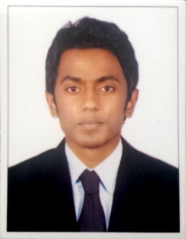
TONY
TONY.367025@2freemail.com

Career Objective

Seeking a challenging career and excellent growth in a well established organization where i can implement my skills and abilities gained through my education and experience and accounts field.

Professional Experience

* Accounts assistant in JOHNY PAUL &CO (November 2013- april 2014)
* Internal auditor in SML FINANCE PVT LTD (October 2014- march 2016)
* Accounts executive in HEEWAN FINANCELTD (June2016-MARCH2017)

Technical proficiency

MS Office (Word, Excel)
Tally ERP-9

Academic Profile

Degree | Board/University | Year of Passing
M.Com | Bharathiar University | pursuing
B.Com | Bharathiar University | 2016
HSE | Higher Secondary Board | 2010
SSLC | Board of Public Examinations | 2008

Personal Profile:

Age & Date of Birth : 24 years, 5 September 1992
Gender : Male
Nationality : Indian
Marital Status : Single
Languages Known : English, Malayalam& Hindi.
Visa Status : Visit Transferable
Driving License : Indian

Declaration

I hereby declare that the above particulars furnished by me are true to the best of my knowledge and belief. I assure you, if I am given a chance, I will execute my work to the fullest satisfaction of my superiors.

