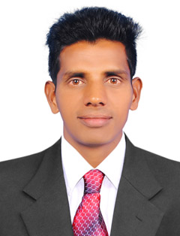 ANTO
ANTO.367039@2freemail.com

OBJECTIVE
- To provide efficient solution to assignment through my technical and analytical skills and serve the best of my ability and keep up my company’s reputation and to grow along with the organization.

- A highly motivated and enthusiastic person, efficient in accounts oriented process that meets customer’s requirements with good quality.

Work Experience:
Jacky’s Motors (India) (From 2014 July to Oct-2016)
Designation: Sales and Accounting
Responsibilities
- Taking care of sales and services of two wheelers and Booking the entries in the system.
- Informing the customers about the services dues in advance.
- Outstandings Receivables follow ups.
- Re – Order the two wheelers according to the requirement.
- Customer Aqusition.
SAJA Electro Mechanical Contracting LLC (Ajman UAE) (From Jan 2014 to May 2014)
Designation: Office Assistant
- Making Invoice.
- Time Sheet.
- Salary Preparation.
- Handling Petty Cash.
IT SKILLS
- Microsoft Word.
- Microsoft Excel.
- DTP.
- Adobe Photoshop.

STRENGTHS
- Willingness to learn new things.
- Resourceful and Hardworking.
- Ability to grasp information quickly.

EDUCATIONAL PROFILE
Course | Instituition / University | Year | % Marks Obtained
B.Sc Computer Science | St.Jude’s College, Thoothoor | 2009- 2013 | 62.9
H.S.C | St.Aloysius H.S.S Marthandanthurai | 2005-2007 | 50
S.S.L.C | St.Aloysius H.S.S Marthandanthurai | 2004- 2005 | 52

PERSONAL PROFILE
Date of Birth : 14.06.1989
Gender : Male
Marital Status : Single
Nationality : Indian
Languages Known : English, Tamil and Malayalam

DECLARATION
I hereby declare that the above-mentioned information is correct up to my knowledge and I bear the responsibility for the correctness of the above mentioned particulars.

