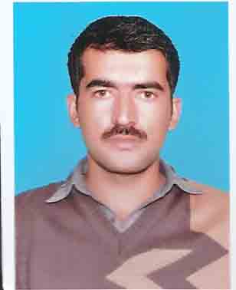

NAveed Visit VISA – valid till “30-JULY-2017”
NAveed.367042@2freemail.com
oBJECTIVE |  | My goal is to become associated with a company where I can utilize my skills and gain further experience while enhancing the company’s productivity and reputation.
Education |  |  |  | ACCA Fundamental , United Kingdom  Higher Secondary School Certificate, BISE Sargodha, Pakistan  Matriculation (Secondary School Certificate) , BISE Sargodha, Pakistan
IT and Accounting Software Skills |  |  |  | Tally  Oracle Financial  QuickBooks  MS Word ,Excel, | User Level Certification  User Level certification  General User with Full automation and system designing.  Advance Level User
Experience |  |  |  | accountant: Shan Departmental Store Peshawar( Tenure 2 year)  Responsibilities:  - Account Receivables & Aging, Account Payable & accruals, financial control.  - Debt Financing, Internal control, Supervision General Ledger maintenance & management.  - Review Follow up claims Invoices, Approved Payments & Purchase Order, Fixed assets, management & disposal.  - Financial control, Debt Financing, Bank reconciliation, Credit & collection,.  - Financial Reporting, Payroll Administration, Financial Management.  - Cash Flow Management  - Maintaining Fixed Asset  assistant accountant: MASAFI SCAFOLDING SHARJAH (TENURE oNE MONTH)  Responsibilities:  - Bank & Cash reconciliation, cleared check differences, bank fee anomalies, targeted balance calculations and enhancements to online services, Bank liaison.  - Claims preparation, General Ledger reconciliations. Accounts Payable and Accruals.  - Proper Filing System, Allocation of prepaid Expenses  - Accounts Receivable, Invoices, and Bad & Doubtful Debts reports ,Adjustment & Closing entries  - Payroll management of staff including worker overtime  - Accounts Receivable, Invoices, and Bad & Doubtful Debts reports ,Adjustment & Closing entries
Achivements |  |  |  | - Design & maintain proper filing system.  - Met deadlines consistently.  - Built a strong internal control and transaction control to avoid duplicate payment.  - Reduce cost of sales by giving proper cost and benefits analysis.  - Build strong internal control to overcome theft and over expenditure.
Languages |  |  |  | English, Urdu, Pashto.

I hereby certified that the above information are true and correct with all my knowledge and also to the help of our ALLAH. After you’ve reviewed my resume, I would welcome an opportunity, and believe that my serivices & skills will be added value to your company’s goals. I would prove my self and become a vital member and asset of your organization.

Naveed

