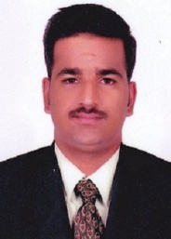
Curriculum Vitae/Resume

VINEETH.367046@2freemail.com
SHARJAH, UAE

Professional Objectives:

To work in a firm with a professional work driven environment where I can utilize and apply my knowledge, skills which would enable me to grow while fulfilling organizational goals.

Educational Qualification

- Master of Computer Applications[M.C.A] –University of Calicut Dr.john Matthai Centre,Aranattukara,Thrissur during the year 2011-14 with 67% .

- BSc Electronics -.University of Calicut
College Of Applied Science,Kuzhalmannam(CASK) with 68.41% aggregate in the year 2011

- Higher Secondary Education (plus two)
Lakshmi Narayana Vidya Nikethan,Ottapalam affiliated to Central Board of Secondary Education with 67% in the year 2008

Work Experience:
1.Content creator cum office admin at Rezolve digital Space,kochi from april 2015 to Jan 2017
Major responsibilities included developing content for websites based on clients requirement that can enhance their business. To work on increase the level of sales and business , maintain key contacts with key clients, office management, records management and general administrative and secretarial services, participate in developing and implementing administrative management policies, working with management in planning organizational needs.

Areas of Specialization
Web-content writing ,Data entry, php ,html-css, ms office

Languages known
English : read-write-speak
Hindi : read-write
Malayalam : read-write-speak

DECLARATION

I hereby declare that all the above mentioned information is correct as per my knowledge. All Certificate and Document would be accessible upon request.

