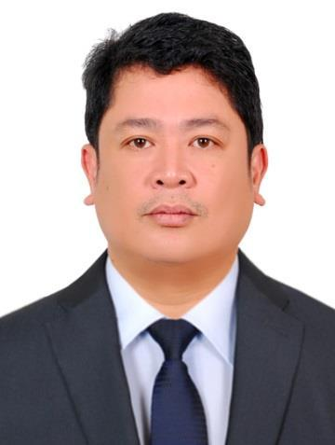

Allan
Allan.367056@2freemail.com

OBJECTIVE:

A dedicated professional with a deep knowledge in technical fields, benefited from the experience of working effectively in an Oil & Gas company and Real estate field, looking for a suitable position in an esteemed organization where my knowledge and experience can be utilized.

EDUCATIONAL ATTAINMENT:

College Degree: Hotel and Restaurant Management De La Salle University- Dasmariñas 1992-1996

WORKING HISTORY:

- SEAOIL PHILIPPINES INC., Philippines 2006 to 2017

Work Position: Distribution Assistant/Foreman
  - Monitor and ensure the safe operation of all fuel movement

  - Supervises oil movement personnel and maintains over-all support on operation and reportorial requirements.

  - Supervises the activities of oil movement personnel.

  - Monitor activity in the area of responsibility and ensure the procedure is carried out according to company procedure.

  - Ensure the security and safety of stored oil products and its facilities.

- METROGATE ESTATE, Philippines 2003 to 2006
Work Position: Landscape artist assistant
- Reads landscape plans.

- Carry out what the landscape plan needs to be done.

- SALES AND MOBILE TECHNICIAN SHOP (OWNER). 1997 to 2002
Work Position: Cellphone Technician & Sales Clerk
- Repair of defective cellphone units

- Bench Corporation 1996 to 1997
Work Position: Sales Clerk

- Responsible for having a thorough knowledge of each item present in the store and must try to sell it to as many people as possible.

- Ensuring the fact that enough pieces of each item are present in the store and there is no shortage.

- Satisfied the customer with regards to the services and looks forward to coming back again.

- Jollibee Fastfood Restaurant 1993 1995
Work Position: Service crew (working student)

- Taal Vista Hotel – Tagaytay City 1991 to 1992

- Assisting hotel guest to their room / suites.
- Keeping the room in order

Seminars Attended:

- Cebu Pacific Flight Steward Training Seminar
- Fire Brigade Training ( Subic Bay Metropolitan Authority)

Other Skills

Computer literate (MS Word, Excel, )

Cooking

Driving

Knowledge in plumbing and electrical
Landscapin

