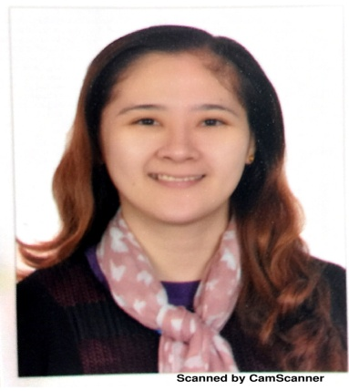
Mai
Mai.367067@2freemail.com

CAREER OBJECTIVE:
To pursue a fulfilling career in nursing and work in an institution where I will be able to enhance my knowledge and practical skills along with a caring attitude and maximize my potentials as a competent and compassionate nurse.

EDUCATIONAL BACKGROUND:
- College: Bachelor of Science in Nursing
Lyceum of Batangas, April, 2006

- High School: Puerto Galera Academy
Puerto Galera, Oriental Mindoro
March, 2002

LICENCES:
- HAAD passer - April 25, 2017
- Passer of Prometrics Examination-Saudi Council License, March 2012
- Board Passer, Nurse Licensure Examination - June, 2006

LATEST WORKSHOPS AND SEMINARS ATTENDED:
- Basic Life Support - 27 December 2015
- Basic Medication Safety - January, 2016
- Mock Code Blue Drill
- Wound care management and tissue viability
- Preceptorship
- Team Leader Workshop
- Disaster Drill
- Fire and Safety Management

EQUIPMENT USED AND HANDLED
- Volumentric Pump/ Syringe pumps (Alaris/Hospira pump)
- Defibrillator: ZollLifepak 12 Biphasic
- Bladder scan Marissa Hoyer Lift with Sling(for transfer and lifting of patient)
- Chorus Hoyer Lift
- Calypso Hoyer Lift
- Pulse Oximeter(Oximax) Nellor
- IVAC Thermometer
- Ambulatory BP Monitor
- (Oximax) Nellor
- IVAC Thermometer
- Ambulatory BP Monitor
- CryoCuff (arm and Knee)
- Thermoscan (Welch Allyn) Braun
- Thermometer (Temp Plus)
- Electric Blood Pressure Apparatus Dynamap (Welch Allyn)
- Otoscope (Welch Allyn)
- Enteral Infusion ( Kangaroo Feeding Pump)
- Life Scan Glucometer (SureStep Flex, touch screen)
- Vascular Doppler
- Digital Weighing Scale (Seca)
- Digital Bed Scale (for weighing bedridden patients)
- Bed Stretcher
- CPM (continues Passive Motion)Machine
- Percussion Hammer
- Suction Machine (built in –portable)
- ECG machine
- Automated External Defibrillator
- VAC (Vacuum Assisted Closure) Machine
- Sequential Compression Device (Kendall)
- Bariatric Bed
- Airflow Bed (Hill-rom Acucair-Continuous Airflow System)
- Intermec Bar Code (for labeling laboratory specimen)
- Patient Controlled Analgesia Machine (PCAM)
- Epidural Catheter

WORK EXPERIENCES:
Staff Nurse II - Male Surgical Ward
January 30, 2012 - February 4, 2017
Ministry Of National Guard Health Affairs - King Abdulaziz Hospital
Al Ahsa, Kingdom of Saudi Arabia

Staff Nurse - Medical Surgical Ward
January 19, 2009 – December 24, 2011
University of Sto. Tomas Hospital
Espana Street, Manila, Philippines

I certify that all the aforementioned information herein are true and correct to the best of my knowledge.

