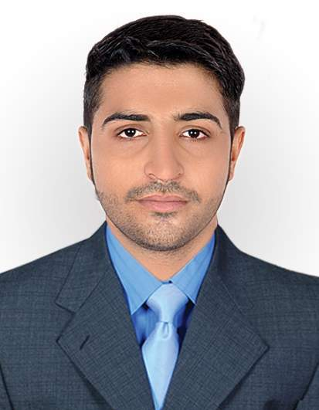
Vivek
Vivek.367081@2freemail.com

PROFILE
Current Accounts & Administrative Office Manager. Versatile, reliable and efficient with 2+ years experience supporting managers and executives in high paced environments. Diversified skills include client relations, human resources, recruiting, project management, and administrative support. Excellent phone and digital communication skills.
PROFESSIONAL EXPERIENCE
Admin And Accounts, Safco Support Foundation
Hyderabad, Pakistan (January 2015-Present)
Core Duties & Responsibilities
- Maintains accounting records by making copies; filing documents.
- Reconciles bank statements by comparing statements with general ledger.
- Present ideas and their execution in a smooth way.
- To ensure that the Branch Is working as per the defined company policies and procedures.
- Act as focal point for all related issues of the assigned Branches and also co-ordinate with different departments to ensure smooth operations at the Branch.
- Greet customers with radiant and positive behavior in telling them the Company Policies, Loan procedure And Repayment Schedule
- Verification on Our Bank’s Database System.
- Verification On State Bank Data Base For The Loan Default And Defaulter Clients From Another Banks.
- Maintain Inflow And Outflow Of Cash Of Branch To Bank.
- Caretaker Of Petty cash Of Branch
- Maintain Field And Official Expenses
- Make Monthly Progress Reports At The End Of The Month.

EDUCATION

- University of Sindh, Hyderabad, Pakistan
Bachelors of Economics (B.A Part 1) Jan 2016- Dec 2016
Bachelors of Economics (B.A Part 2) Jan 2017- Continue

- Memon Academy Higher Secondary School, Shahdadpur, Pakistan
Higher Secondary School Certificate in Engineering Aug 2011-Aug 2013

Key Competencies
- Acting as a Team Player
- Worked as Event Coordinator
- Ability to accept & learn from criticism
- Working well under pressure
- Sales Report and Correspondence
- Good Vendor, Staff and Customer relations skills
- Innovative thinking strategy
- Self-Discipline
Leadership Skills
- Achieved various Academic Awards and Merit certificates
- Excellent Interpersonal, Presentation and Communication Skills

Computer Skills
- Microsoft Word
- Microsoft Excel
- Microsoft PowerPoint
- Google Earth
- Good browsing & searching techniques

Soft Skills
- Positive Attitude
- Time Management
- Adjustable in almost every environment.
- Problem Solving Skills
LANGUAGES
- English- Excellent reading, writing and speaking
- Urdu/Hindi -Native proficiency
- Sindhi-Native proficiency
OTHER INTERESTS
- Team Player, Volunteering, Reading, Music and Playing Cricket.

Trainings
- Essentials Of Accounts And Admin In HID Safco March 2017

REFERENCE
- References can be furnished upon request.

