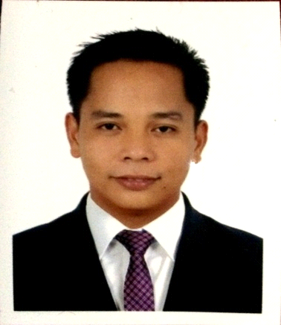BRENT
BRENT.367084@2freemail.com

OBJECTIVE
- To obtain a position as a barista waiter in an upscale cafe& restaurant
- Willing to work in a dynamic challenging and growth oriented company that’s allows me to utilize my knowledge and experience to contribute for the growth of the organization.

WORK EXPERIENCE

WAITER, BARISTA
Holiday Inn Al-Qsar 4 *hotel Kingdom of Saudi Arabia (Riyadh)
2011 – 2014

BARISTA,WAITER
CAMPUS CAFE &RESTAURANT
ABU HAIL DUBAI U.A.E.
2015 Up to present

Duties & Responsibilities:
- Make coffee connections such as latte art 3d art espresso cappucino juice mixes.
- Cleaning Espresso Machine Grinders,blender juice etc.
- Provide all customers with fast friendly personalized service and develops a rapport with customers by learning their names favorite drinks and food items.
- Maintains the highest level of standard for all product preparation including proper grinding of coffee beans and top quality espresso shot
- Develop an understanding of coffee regions and the various differences in flavor and blends.
- Begins to educate themselves on the various types of coffee products blends and roasts
- Initiates suggestive selling and sampling of product
- Contribute to the profitability of the cafe by finding new methods of selling products.
- Routinely cleans the bar area floor food display cabinet and takes out trash,etc.
- Understand and adheres to proper food handling safety and sanitation standards during food & beverage preparation service and clean up.
- Any other appropriate duties and responsibilities as assigned

SPECIAL SKILLS
- Computer literate
- Great communication skills
- Ready to face challenges
- Sincere dynamic and hard working
- Teaching others how to do something.

EDUCATIONAL ATTAINMENT

College 2004-2008 BACHELOR of SCIENCE in NURSING
Lyceum of Aparri Macanaya Aparri Cagayan Philippines

I HEREBY CERTIFY that the above information is correct to the best of my knowledge and belief.

BRENT
Applicant

