Usman
Usman.367093@2freemail.com 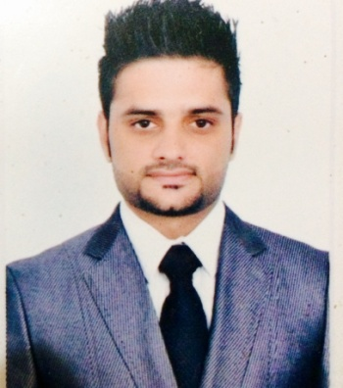
To grab a position that allows me to use and improve my skills. Looking forward to take big responsibility to serve and show my skills.

SUMMARY OF PERSONAL STRENGTH
a) Educated to Degree level is likely to demonstrate a thorough understanding,
Interpretation and application of theories and processes aligned to sales &
Relationship strategies.
b) More than 2 years experience in a similar sales position.
c) Proven record of accomplishment in a sales and targets environment.
d) Proven track record within markets through field sales and partner
Channels.
e) Will have a well developed network of contacts.
f) Good relationship building & influencing skills, up to executive level.
g) Aid and efficiently contribute in the regional operational plan to achieve
Sales objectives.
h) Achieve division Objectives / Achieve forecasted sales targets.

UAE EXPERIENCE
national trading and development est. Dubai
From 11 AUGUST 2009 to 20 November 2011

Sales Executive :
- Services existing accounts, obtains orders, and establishes new accounts by planning and organizing daily work schedule to call on existing or potential sales outlets and other trade factors.
- Focuses sales efforts by studying existing and potential volume of dealers.
- Keeps management informed by submitting activity and results reports, such as daily call reports, weekly work plans, and monthly and annual territory analyses.
- Monitors competition by gathering current marketplace information on pricing, products, new products, delivery schedules, merchandising techniques, etc.
- Resolves customer complaints by investigating problems; developing solutions; preparing reports; making recommendations to management.
- Provides historical records by maintaining records on area and customer sales.
- Contributes to team effort by accomplishing related results as needed.
- Conducting successful product promotions at key outlets.
- Close monitoring and vigilant eye on sales status, collection and after sales
Service.
- Achieving targets and increasing sales of my Company.
- Having a good relationship with Managers and Customers.

Qais enterprises ltd Pakistan from jan 2012 to jan 2014
leading distribution of vaccine and medicine for poultry diseases
Marketing manager

- monitering all the frunchise in my area with there progress and customer services
- handeling deals with all the poultry farm managers at high level
- look forward to get business and gain more customers for company
- maintaining stock and products at all outlets under my area
Free lancer modeling and fashion shows ,brand promotions (part time 2012-2016)
I have done fashion shows, photo shoots localy in pakistan for clothing brands at best level for more detail please visit my facebook page (http://www.facebook.com/uhjofficial)

BASIC QUALIFICATIONS

- I.C.S 2002( Board of intermediate & secondary education Gujranwala Pakistan

SKILLS

Customer Service, Meeting Sales Goals, Closing Skills, Territory Management, Prospecting Skills, Negotiation, Self-Confidence, Product Knowledge, Presentation Skills, Client Relationships, Motivation for Sales.

OTHER QUALIFICATION

GP3 Sea man diploma holder from professionals maritime education and training institute from Karachi Pakistan in (2007-08) with all basic courses.

PERSONAL DETAILS
Nationality : | Pakistani
Date & Place of Birth : | 3rd-August-1985 Pakistan
Religion : | Islam
Marital Status : | Single
Visa Status : | Visit Visa

LANGUAGES KNOWN
Fluently speak English, Urdu & Punjabi. Arabic (Basic)

Visa status: visit visa (valid til june 24)

REFERENCES
Will be provided upon re quest.

I hereby certify that all above information is true and correct

USMAN

