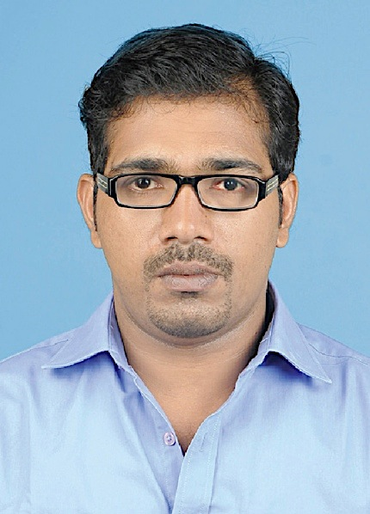

NOORUDHEEN

ABDULLA

Graphic Designer \ Artist\

Pre pro Graphic Designer

RESUME



Profile

**PROFESSIOAL SKILLS ARE**

* **Drawing and Painting**
* **Artistic Sensibility**
* **Technical Skill**
* **Organization**
* **Problem Solving Ability**
* Working within brand guidelines

Highly creative and versatile graphic designer who worships art. I have multitude of experience in the field of Advertising & Print media. I connected abstraction to design. Worked with renowned and multi-national firm in india and UAE. Currently based in Dubai

Diploma in Fine Arts (KGTE)

Thalassery Fine Arts College (Kerala-India)

Courses : Pencil Drawing, Live Sketch, Water Color, Vinyl Cutting

Diploma in Graphic Design

Windowsoft Computer Education Centre (Kerala-India)

#### Courses : Adobe Photoshop, illustrator, indesign, Corel Draw, pagemaker,

#### quark express

#### Secondary School

Board of public examinations Kerala, India.

Pre Degree

MG College Madappally Under Calicut University (Kerala-India)

Education



#### Graphic Designing tools Adobe Photoshop, illustrator, indesign

#### Corel Draw, page maker, quark express, PDF

Office automation using MS Office

Working with Mac OS and Windows

Computer Skill

­



The Printer LLC - Dubai

Working as a graphic designer and CTP Operator

Al Mahri Advertising - Dubai

Worked as a graphic designer and Silk Printer

Thejas Daily and fortnightly - India

Thejas Daily is a one leading News Paper from the Kerala, worked as a designer (News Paper & Magazine)

Midas Offset Press - India

Worked as a graphic designer

Nakshatra Events - India

Worked as a backdrop designing and supervising

Surya Advertising - India

Worked as a artist

Design Thought Interior - India

A leading Interior designing company in Bangalore (Karnataka)

Worked as a artist and Site Supervising

Noorudheen Abdulla

Work Experience

Information’s

Nationality: Indian

Passport No: F6943218

Religion : Islam

Address:

Abdulla Manzil House

Pathayakunnu Post

Kannur Dist, Kerala St.

Current Address

Al Qusais, Dubai-UAE

Mobile :

+971 56 281 1234 (Dxb)

+91 956 224 8838 (Ind)

E-mail :

[dheenu7@gmail.com](mailto:dheenu7@gmail.com)

[dheenu9@yahoo.com](mailto:dheenu9@yahoo.com)

Visa Status :

Expiry on 2017 July

