Eman
CONTACT:

E-mail: eman.367125@2freemail.com

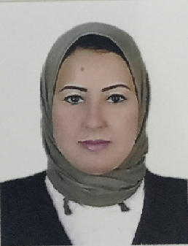

JOB OBJECTIVE:
To obtain a full time position in the field of any suitable Department that will allow me to contribute to the organization having global image using my experience, competency and creativity, in self-motivated environment.
SKILLS:
- Business development
- Maximizing sales
- Exceeding targets
- Customer relationship
- Negotiating & Networking
- Strategic planning
- Quality assurance
- Business planning
IT skills:
- Proficient with the Microsoft Office suite, navigation of the internet as a research tool, Opera, Marsha,
INTERESTS:
- Reading books
- Listening music

Nationality | : | Egyptian
Date of birth | : | 25th May, 1991
Gender | : | Female
Marital status | : | Married
Languages | : | Arabic , English
Current location | : | Ajman– UAE
Visa Status : Residence (Husband Visa)

EDUCATION
2010-2013 | : | Faculty of Sciences – Alexandria University

WORK EXPERIENCE

Quba Primary School :-
Job Title :- Sciences Teacher
From :- 20th September 2013
Until :- 25th May 2014

Sato Pharma:-
Job Title: - Medical Representative
From: - 02nd September 2014
Until: - 15th August 2016
Job Description:-

- organizing appointments and meetings with community and hospital-based healthcare staff
- identifying and establishing new business
- negotiating contracts
- demonstrating or presenting products to healthcare staff including doctors, nurses and pharmacists
- undertaking relevant research
- meeting both the business and scientific needs of healthcare professionals
- maintaining detailed records
- attending and organizing trade exhibitions, conferences and meetings
- managing budgets
- reviewing sales performance
- writing reports and other documents

- Magic Pharma :- 2013 until 2015 – Medical Representative

