DORIS
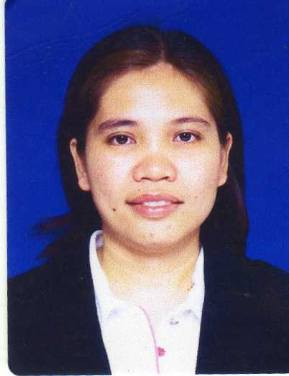
DORIS.367132@2freemail.com

Profile: Female, Married
Nationality: Filipina
Visa Status: Residence Visa (Transferable)

CAREER OBJECTIVE

To explore opportunities that provides continuing challenge and professional growth.

CAREER PROFILE

- Detail-oriented, efficient and organized professional with extensive experience in office works.
- Possess strong analytical and problem solving skills.
- Resourceful in the completion of projects, effective and multi – tasking.
- Fast learner and can easily adapt even to a fast paced industry.
- Highly trustworthy, discreet and ethical.
- Willing to learn other new computer system programs quickly.

PROFESSIONAL EXPERIENCE

Unikai Foods P.J.S.C.
P.O. Box 6424, Dubai, UAE
Position: Accountant (August 25, 2016 up to present)

Responsibilities :

- Prepare Accounts Receivable Aging/schedule monthly,
- Sending monthly statements to customers, follow-up/ monitor for customer’s payment.
- Checking invoices, posting receipts, credit notes (Goods return & rebates) / debit notes
- Reconcile customers account regularly.
- Prepare Sales Commission calculations monthly.
- Prepare Rebates calculations monthly.
- Assist Credit Controller in creating new customers account/ Checking Credit limit.
- Assist / Liaise with Auditors regarding AR account.(Quarterly Audit with KPMG)

National Refreshments Company LLC (FMCG)
P.O. Box 1880, Dubai, UAE
(Beverage Manufacturing/ Distrib.)
Position: General Accountant (June 28, 2008 to August 20, 2016)

Responsibilities :

- Prepare monthly Financial reports (Balance Sheet/ Income Statement & other Managerial/Analysis reports)
- Prepare Accounts Receivable Aging/schedule of AR monthly, sending monthly statements to customers, follow-up/ monitor for customer’s payment, posting invoices, receipts, credit notes (Goods return & rebates) / debit notes & reconcile customers account.
- Prepare bank reconciliation report, posting bank transactions daily, monitors daily cash inflow & outflow
- Prepare Accounts Payable Aging/ schedule of AP monthly, review documents, verify the accuracy of invoice against purchase order/items received & expense code allocation, prepare Cash/ Cheque payments to suppliers as per their due date, reconcile supplier’s statement of account
- Prepare / posting journal vouchers for expenses including salaries, depreciation, accrued / prepaid
- Check and review petty cash/ prepare cheque for replenishment
- Monitor /control fixed assets & inventories, posting Store receipt/issue voucher) daily, verify and post all suppliers’ invoices as per their contract price & terms, reconcile stocks/item received compared with the suppliers invoice/ delivery note, conduct inventory/ stock take regularly.

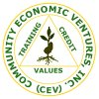
Community Economic Ventures Inc.
Micro Finance Company
(A Parallel organization with World Vision)
Tagbilaran City, Philippines

Position: Area Accountant / Branch Accountant
(December 01, 2001 to May 31, 2008)

Responsibilities :

- Handled 5 Visayas branches
- Review the works of branch accountants
- Review financial reports, including cash flows of the branch
- Conduct surprise cash counts / inventory of assets of the organization
- Checking the internal control of the organization
- Records daily financial transactions
- Maintains books of accounts(general journal, gen. ledger, cash disbursements & receipts)
- Maintains organized files of documents(Cash disbursements/receipts and Journal Vouchers)
- Prepares monthly financial reports: Income Statement, Balance Sheet, Trial Balance, Bank Reconciliation, Schedules of receivables, client savings & interest on deposit
- Prepares Portfolio / Repayment report
- Maintains branch supplies and controls asset

Shell Gasoline Station
Maasin City, Philippines

Position: Cashier
April 01, 2001 to September 30, 2001

Responsibilities :

- Receiving /managing cash from customers
- Prepare daily cash reports and deposit to bank
- Conduct inventory of petroleum products

EDUCATIONAL BACKGROUND

College - Bachelor of Science in Accountancy
Saint Joseph College- Maasin City, Phil.
March 2001(consistent Star JPIAN awardee)

- Diploma in Agricultural Technology
Southern Leyte State University-Bontoc So. Leyte
April 1997 ( DOST-SEI Scholar)

SKILLS AND QUALIFICATIONS

- Ability to establish & implement effective financial policies & procedures
- Expert in budget management, forecasting, marketing and clients services
- Fast learning abilities & hard working
- Good communication skills (fluent in English both in reading and writing)
- Excellent in bookkeeping, attention to detail
- Proficient in Windows application (MS word, Excel)
- Patient, Strong follow-up and monitoring skills

PERSONAL DEVELOPMENT / TRAININGS ATTENDED

- Buckle Up Training A workshop to standardize operational processes with integration of strengthening the internal control for fraud prevention. Held on Nov 27-30, 2007 at Tagbilaran City, Bohol, Phil.

- Internal Audit Training conducted by World Vision National Office held on Aug 23- 27, 2006 at Agricultural Promotion Center, Tagbilaran City, Phil.

- Financial Ratio Analysis Training held on Jan 23-25, 2006 at CEV Training Room Tagbilaran City, Phil.

- RG Assets Training. Computerization training for new product development held on Feb 24-26, 2005 at CEV Training Room, Tagbilaran City, Phil.

- E-merge Training/ Lotus Notes. MIS Training based from Delysis ( foreign MIS) held on June 25 to July 1, 2005 at WV National Office, Quezon City, Phil.

- Zinger - Miller Training / Workshop, a frontline leadership training, completed four modules: Coaching for Optimal Performance, Clarifying Team Roles and Responsibilities, Your Role and the Basic Principles an Giving Constructive Feedback. Conducted by Institute for Transformational Development Foundation, held on July 27-29, 2004 at Agricultural Promotion Center, Tagb City, Phil.

- Transformational Leadership Course ( Based on Seven Habits of Highly Effective People) Conducted by Institute for Transformational Development Foundation, held on Jan. 20-22, 2003 at Agricultural Promotion Center, Tagbilaran City, Phil.

- Post Selection and Enhancement Training ‘ Towards Efficiency & Sustainability as Pri-movers in Helping Small Business Grow”. Conducted by CEV, Inc. on Oct 15, 2001- Nov 29, 2001 at CEV Main Office, Tagbilaran City, Phil.

- Bookkeeping Seminar/ Workshop conducted by PICPANS Maasin Chapter held on Nov 18-19, 2000 at SJC, Maasin City, Philippines.

