CURRICULUM VITAE
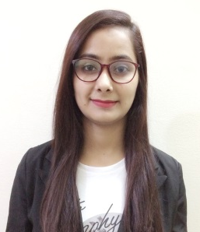

Bhawana

Bhawana.367146@2freemail.com

Personal Summary

An Accountancy Graduate with a total of 3 years’ experience in Accounting in India. A proven ability to support & improve efficiency by supporting and managing day to day activities of Accounting.

Objective

Accountancy graduate with good academic standing applying for a General Accounting position where I can use my knowledge and experience to ensure the delivery of all financial and accounting activities related to accounts payable, accounts receivables and general accounting.

Qualifications:

- B.com from MDS UNIVERSITY, AJMER (RAJASTHAN) in 2016.
- Completed M.COM Previous from MDS UNIVERSITY, Ajmer Rajasthan

Work Experience:

- Work at BRD Real Estate as an Accountant.
August 2014 — Dec. 2015
- Work at Sunfield Textile and Sunfield Realtors as an Accountant
March 2015 — Jan. 2017

Job Responsibilities

- Supervise all regular Accounting Processes such as Journal Entries plus Monthly closure accounts.
- Analyze and Forecast financial requirement for organization.
- Management of petty cash transactions.
- Reconciliation of direct debits and finance accounts.
- Ensuring all payments amounts & keeps records accurate.
- Verifying balances in account books and rectifying discrepancies
- Verifying bank deposits & completing bank reconciliation
- Analyze different Journal general ledger account regularly.
- Handle Book keeping tasks.
- Prepare Profit & Loss Statement on behalf of organization.
- Preparing financial documents such as invoices, bills, and accounts payable and receivable
- Performed general office Duties & Administrative Tasks.

Computer Proficiency:

- Well conversed with windows, MS Office, excel, power point Internet, etc.
- Having knowledge of computer accounting “Tally-ERP”.
- Reviewed Textile Accounting Software Like Face Soft.

Personal Attributes:

- Confident, self-motivated, Energetic and willing to work in demanding circumstances.
- Good perception and vision.
- Skilled in scheduling, communication, coordinating, team building and human management.
- Adjustable in any circumstances.

Personal Information :

Date of Birth : 20th April 1995
Marital Status : Unmarried
Nationality : Indian
Language Known : Hindi, English and Sindhi
Visa Status : Visit Visa till the 29th June 2017

References

Available on request.

