**Education**

* Completed B.com Honours in 2016 from University of Sargodha, Pakistan
* Completed D.com in 2012 from Punjab Board of Technical Education Lahore, Pakistan

**Professional Experience**

**Cresent Socks Pvt.Ltd,Lahore,Pakistan (July2106-March2017)**

**Accounts**

* An accountant with nearly 2 Year of rich experience in Accounts, Finance, Taxation & Costing, Designated asAssistant Accountant (Finance & Accounts) with Cresent Socks Pvt. Ltd
* Managing the maintenance of Accounting System & financial statements including P&L Account and Balance Sheet, ensuring conformance to time, accuracy and accounting standards
* Preparing and maintaining necessary stock records to track the inward / outward movement of goods; conducting stock verification / reconciliation at regular intervals
* Preparing reports on performance of company
* Adequate experience in restructuring Accounting Systems as well as sales accounting, sales Reconciliation, Debtor reconciliation, cash handling &accounting, Bank reconciliation, statutory payments ,Employees accounts Maintain of General ledger ,internal auditing, inventory verification.

My responsibilities include:

* Closing books of account and finalisation of Financial Statement
* Preparation of Annual Report
* Checking and analysis of monthly expense and provisioning of expenses
* Reconciliation of accounts of Branches with head office
* Checking Accounts payable and Account Receivable

**Internship in ZTBL,Sillanwali Pakistan(June2015-Sep2015)**

**Internship in HBL,Sargodha Pakistan(June2014-Sep2014)**

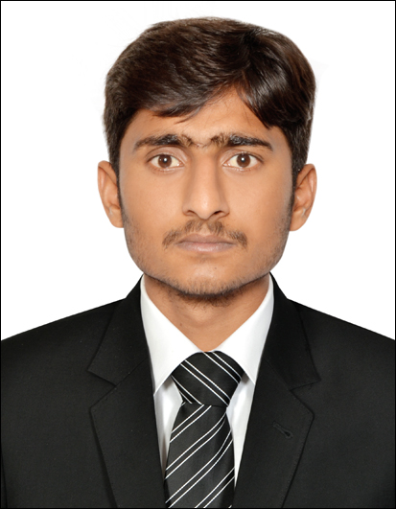

* Accounts Handling
* Consumer behaviour and ways to handle it
* Business Communication
* Basic financial and management accounting
* Retail market and its distribution
* Advertising and branding
* Establishing and maintaining Public Relation

***LANGUAGES***

* ***English***
* ***Urdu***

***PERSONAL INFORMATIONS***

08th Sep, 1994

Single

Pakistani

Visit Visa (22 March - 20 June 2017)

**Profile Summary**

To pursue a highly challenging career in the field of Accounts ,Finance. where I would apply my knowledge, experience and ideas to develop high calibre professional skill and effective management technique by proactive research and development activities to ensure protection of interest of industry and emerge as a good Corporate Professional.

.

***Will be furnished on demand***

***REFERENCE***

***SKILLS***

**Asad**

[**Asad.367151@2freemail.com**](mailto:Asad.367151@2freemail.com)

Accounts&finance