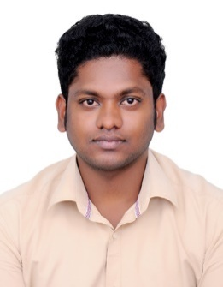
ABINESH
ABINESH.367206@2freemail.com

Brief Profile:
Diploma in Automobile Engineering technician with 4 plus experience as Production technical supervisor in a leading four-wheeler and Two-wheeler manufacturing units at India. Currently placed in Dubai looking for better opportunities to enhance my technical skills and career.

Brief work Experience:
Royal Enfield Motors LTD.
Designation : Maintenance Technician in vehicle assembling.
Period : 1 Year and 10 Months From 12/05/2012 to 12/02/2014

Roles and Responsibilities:
- Monitoring Assembly section of vehicles and reporting to Head supervisor.
- Checking the quality of the breaking system of each and every motors.
- Guiding the Junior trainees on technical work procedures and outcome.
- Giving 100% quality assurance on every motors to satisfy RD Customers worldwide.
- Assistance on Automotive breaking system instead Manual.

Susee Auto Zone (P) Ltd. (Tata Motors):
Designation : Technical Supervisor.
Period : 1 Year and 1 Month From 03.03.2014 to 31.03.2015

Roles and Responsibilities:
- Single point of contact for customers on service and delivery department.
- Checking quality of every vehicle opt out after service.
- Maintaining customer satisfaction on delivering vehicles.
- Cascading the defects of the vehicles come for service point to service technicians and make sure the customer complaints fixed.

Vistion Automotive System Pvt. Ltd.:
Designation : Production and Maintenance Technical Supervisor.
Period : 1 Year and 1 Month From 22.04.2015 to 20.04.2016

Roles and Responsibilities:
- Handling the team of 15 technicians in Vehicle assembling section.
- Vision Automotive System Pvt Ltd who provides service offers on AC, Radiators, Condensers for the leading motor vehicles (Ford, Hyundai etc).
- Worked on Vent assembling parts and quality checks.
- Production support and Assembling support.

Strength
- Focused
- Capable of working in team
- Urge to learn new things.
- Adhere with 3C&5S Global concept on Customer satisfaction in work ethics.

Extra-Curricular:
- Attended Seminar on “Opportunities and Challenges in Renewable Power Generation” Held at Cape Institute of technology.
- Interested in Knowledge transfer to trainees and guiding them for success.

Education:
- Diploma in Automobile engineering with aggregate of 72% at Cape College of Engineering – Aralvaimozhi and period of 2009 to 2012
- Higher Secondary education at S.M.R.V. Hr. Sec. School, Vadasery with 68% and 2009 passed out.
- Secondary School completion at 2007 at S.M.R.V. Hr. Sec. School, Vadasery with 48%

Declaration:
I hereby declare that the above mentioned information is true to the best of my knowledge and belief

