CURRICULUM VITAE
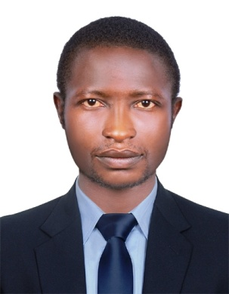
PERSONAL INFORMATION
Name : FORWAH DANIEL
FORWAH DANIEL.367215@2freemail.com
PROFILE
Dedicated security professional with more than 3 years experience managing teams in retail and corporate environments. Personable leader who comfortably interacts with people from diverse cultures and backgrounds. Resourceful and creative problems solver with expertise in building and personal security.
JOB OBJECTIVE
Honest, talented and dedicated Hotel Security Guard seeking a job within your organization where I can play a major role in the execution of duties.
HIGHLIGHTS OF QUALIFICATIONS
- Highly experienced in hotel security services
- Profound knowledge of customer service policies.
- Huge knowledge of security techniques
- Amazing ability to adapt to changing environment
- Immense ability to work in flexible schedules
- Remarkable ability to work effectively with cross-functional teams
- Excellent verbal and written communication skills

PROFESSIONAL EXPERIENCE
Hotel Security Guard
Etta Palace Hotel Buea( South West Region of Cameroon)
August 2014 – January 2017
Responsibilities:
- Welcoming guests, taking out their lugguages from the car as well as directing them to the check in desk.
- Assist the guests by taking their luggages into their rooms
- Ensured safe environment for hotel employees and guests.
- Escorted Cashier during transportation of valuables.
- Protected guest’s luggage from theft and damages.
- Addressed all guest queries and complaints.
- Provided first-aid services when needed.
- Controlled crowd during busy times.
- Managed building maintenance operations.
- Assisted in development of energy reservation programs.
Hotel Security Guard
Chariot Hotel Buea( South West Region of Cameroon)
May 2013 – May 2014
Responsibilities:
- Handled emergency situations in an efficient manner.
- Addressed security concerns promptly.
- Investigated incidents and developed detailed incident reports.
- Patrolled hotel premises to detect any crimes.
- Ensured all employees follow security standards.
- Identified safety hazards and recommended appropriate measures.
- Controlled violent person without disturbing hotel operations.
- Determined safety violations and reported to Manager.
LANGUAGE PROFICIENCY
- ENGLISH : Fluent
- FRENCH : Fair
EDUCATION
- Diploma(HND)
- Advance level certificate in sciences
- Ordinary level certificate in sciences
- First school leaving certificate

