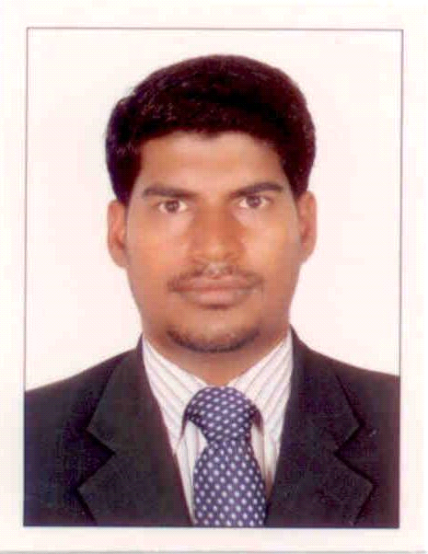 Resume

Dnyaneshwar
Dnyaneshwar.367239@2freemail.com

Professional Synopsis
- Graduate with experience of 8 years in sales, business development, recruitment & operations’ management involving
- Sales - Business Development - Recruitment - Planning & Management - Administration - Consultancy
- A keen planner & implementer with devising administrative plans and ameliorating the revenue growth.
- Team Leader with skills in monitoring, mentoring & motivating team members to accomplish the service delivery norms. An effective communicator with honed analytical, problem solving & organizational abilities.
- Proven abilities in streamlining the pre-existing systems/ processes to enhance operational effectiveness.

Educational Credentials Bachelors in Commerce (Mumbai University – 2002)

Career Highlights:
National Bank of Abu Dhabi From 15 th Nov .2016 To Till Date.
Senior Sales Officer Personal Loan Dept.

• Identify new customers for the bank which generates new business in form of Retail Assets Products.
• Managing customer centric banking operations forwarding customers instructions to the concerned department.
• Ensuring customers satisfaction by achieving delivery & services as per quality norms.
• Achieving the sales target through selling of core products and cross-selling.
• Coordinate with the bank official to generate and procure more business.
• Managing customer centric banking operations, forwarding customer instructions to the concerned department & ensuring customer satisfaction by achieving delivery & service quality norms.

Noor Islamic Bank : From 2 nd November 2015 to 30th October 2016
Senior Sales Relationship officer

• Identify new customers for the bank which generates new business in form of Retail Assets Products.
• Managing customer centric banking operations forwarding customers instructions to the concerned department.
• Ensuring customers satisfaction by achieving delivery & services as per quality norms.
• Achieving the sales target through selling of core products and cross-selling.
• Coordinate with the bank official to generate and procure more business.
• Managing customer centric banking operations, forwarding customer instructions to the concerned department & ensuring customer satisfaction by achieving delivery & service quality norms.

Abu Dhabi Commercial Bank - Sept 2014 To 30 th Oct. 2015
Sr. Relationship Officer
SME & Retails Cross Sells:

• Responsible to achieve a Monthly & Annual Targets.
• Achieving the sales target through core product of business loan liability and other retail products cross-selling
• Co-ordination with operations team for seamless account opening and minimal customer complaints.
• Coordinate with the bank official to generate and procure more business.
• Identification of Business Development opportunities with existing clients and prospective clients. Assisting client in their financial planning.
• Responsible for opening an business account & maintenance.

Client Relationship:
• Managing customer centric banking operations, forwarding customer instructions to the concerned department & ensuring customer satisfaction by achieving delivery & service quality norms.
• Maintaining healthy business relations with SME and HNI,s Clients

National Bank of Abu Dhabi From 10th Dec.2012 To August 2014
Senior Sales Officer Personal Loan Dept.

• Identify new customers for the bank which generates new business in form of Retail Assets Products.
• Managing customer centric banking operations forwarding customers instructions to the concerned department.
• Ensuring customers satisfaction by achieving delivery & services as per quality norms.
• Achieving the sales target through selling of core products and cross-selling.
• Coordinate with the bank official to generate and procure more business.
• Managing customer centric banking operations, forwarding customer instructions to the concerned department & ensuring customer satisfaction by achieving delivery & service quality norms.

Emirates National Bank of Dubai - April 2011 To 31st Oct.2012
Sales Supervisor Direct Sales Force Credit Card Dept.
• Identify new customers for the bank which generates new business in form of Retail Assets, Casa Products, and Insurance Policy.
• Managing customer centric banking operations forwarding customers instructions to the concerned department.
• Ensuring customers satisfaction by achieving delivery & services as per quality norms.
• Achieving the sales target through selling of core products and cross-selling.
• Coordinate with the bank official to generate and procure more business.
• Managing customer centric banking operations, forwarding customer instructions to the concerned department & ensuring customer satisfaction by achieving delivery & service quality norms.
National Bank of Ras Al Khaimah .- Feb’2008 – 30TH April 2010
Relationship Officer
SME Accounts & Cross Sells:
• Responsible to achieve a Monthly & Annual Targets.
• Achieving the sales target through cross-selling too.
• Coordination with operations team for seamless account opening and minimal customer complaints.
• Coordinate with the bank official to generate and procure more business.
• Identification of Business Development opportunities with existing clients and prospective clients. Assisting client in their financial planning.
• Responsible for account maintenance.
• Portfolio Management and Portfolio Rebalancing with Investment Management Strategies Client Relationship:
• Managing customer centric banking operations, forwarding customer instructions to the concerned department & ensuring customer satisfaction by achieving delivery & service quality norms.
• Maintaining healthy business relations with SME and HNI,s Clients. Manage their investment and Trade portfolios to maximize their wealth.

Sales Development Manager – Sales HDFC Standard Life Insurance Company Ltd. , Mumbai, India Feb’2007 to Jan’2008

Significant Highlights of the Job Responsibility;
- Identify potential Financial Consultants (Insurance Agents) based on agreed profiles and ensure recruitment in accordance with the business plan.
- To achieve targets of direct sales and recruit the minimum expected number of Financial Consultants.
- To identify more Financial Consultants and to complete recruitment of the financial consultants as expected and communicated by the management, within the given time frame. To also achieve minimum expected sales target on a consistent basis through own team of Financial Consultants.
- To continuously review performance of own team of Financial Consultants and to improve their productivity on an on-going basis.
- Provide leadership and management to the team of Financial Consultants.
- To endeavor to have and to achieve a team of highly productive Financial Consultants.
- Provide training and monitor development needs of financial consultants in the team; provide feedback on financial consultant’s performance, particularly those with less experience. (Mentor role)
- Set targets for consultants, review these & consistently raise them.

Sales Officer – Sales NRI Division,
ICICI Bank Ltd., Mumbai, India - May 2003 to Feb 2007

Sales:
• NRI Account Opening, Fixed Deposit,
• Insurance life & non-life visiting to MNC Company for tie-up with bank for for NRI’s account opening.
• Handling team of FOS who are appointing for new sources of business.
Generating Reports:
• The job profile included collation of data to present at various forums within the organization. Construction of documents to capture various client details.
• Keeping a record of performance of the team members.
Team Management:
• Managing a team of Tele-callers & sales officers with varying experience.
• Technical and soft skill mentoring for team members aimed at empowering members to achieve their targets
Professional Achievements:
• Best Relationship Officer for 3rd Quarter in 2008.
• Top SDM in Recruitment for 1st Quarter in 2007.
• Sprint Achievement for Cross Sales of LI of ICICI Prudential.
• Performer Sales Executive in of NRI Dept. West Region in 2006.

Computer Skills
Proficient in using personal computer, primarily Microsoft Office (Microsoft Word & Excel) & Internet Explorer.
Languages Known – English, Hindi & Marathi

Target Job : confirmed job in any organization
Desired Job Type : Full Time Employee
Relocation : Willing to re-locate for better opportunity
Current Salary : AED 78000 /- PA (Plus Conveyance, Incentives, Medical Allowances)

