Curriculum-vitae

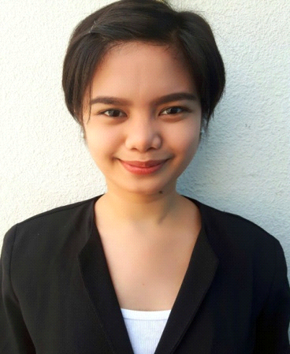  Personal Data:  Name :  HILDA  HILDA.367247@2freemail.com  DATE OF BIRTH:  6th, March 1994  GENDER:  Female  NATIONALITY:  Filipino  RELIGION:  Christian  MARITAL STATUS:  Single  VISA STATUS:  Tourist Visa  LANGUAGE:  English | POSITION APPLIED FOR: SALES ASSOCIATE CUM CASHIER  OBJECTIVE  To contribute to the success of an organization through my in-depth knowledge and skills related to my field. And to develop my talent and skills for continuous career improvement.  EMPLOYMENT HISTORY  GUESS  (From Dec, 2015 – March 18, 2017)  Job Title: (SM City Baguio, Philippines)  DUTIES/ RESPONSIBILITIES  - Working as a cashier and assisting customers.  - Providing a high quality of customer service.  - Helping to build the business by exceeding customer expectation,  - Prepare daily cash float, handling daily transaction in different kind of mode of payment using POS.  - Maintain accurate records of all transaction.  - Vigilant assessing and identify fraudulent card, addressing customer to exchange and refund policy.  - Promote ongoing sale promotion and other new arrival.  - Apply the Up-selling techniques and cross selling to achieve the target.  DEPARTMENT OF EDUCATION  (From May, 2015 – November 2015)  Job Title: CLERK (La union, Philippines)  DUTIES/ RESPONSIBILITIES  - Answers telephone, transfer calls to appropriate person.  - Greet all visitors coming into the office and direct them to the appropriate person or department.  - Perform general office duties including data entry typing and filling.  EDUCATION ATTAINMENT  AMA Computer College  City of San Fernando , La union, Philippines  COURSE: Bachelor of Information Technology  School Year (2011-2014)  TRAINING ATTENDED :  FREE OPEN SOURCE SOFTWARE  - Don Mariano Marcos Memorial University(DMMMSU)  City of San Fernando, La union  February 26, 2012  NETWORK SECURITY AND LINUX SEMINAR  - Don Mariano Marcos Memorial University(DMMMSU)  City of San Fernando, La union, Philippines  February 26,2012  FLUKE NETWORKING  - AMA Computer College  City of San Fernando, La union, Philippines  September 29,2012  BASIC OPERATION TRAINING PROGRAM  - Guess Main Office  Baguio City, Philippines  August 2015  MISCELLANEOUS  - IT- skills - Microsoft ( Word, Excel, Power point, Computer Reformatting)  - Jobs Skills – Team Player, Self Motivated, Proactive, Organized  REFERENCES  Upon Request  DECLARATION:  I hereby declare that the above information is true to the best of my knowledge and belief and nothing has been concealed or distorted

