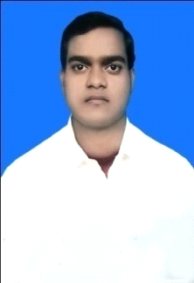
RESUME

FAIYAZ
FAIYAZ.367263@2freemail.com

Objective: To be a creative, competitive, challenging with growth oriented career to optimally utilize, enhance my skills and excel it by hard work and determination.
Academic Qualification:
Qualification | Institution | University/Board | Year of  Passing | Percentage of marks
GRADUATION B.Com. (Hon) | R.S.P College  Jharia | VINOBA BHAVE UNIVERSITY | 2013 | 53.00%
Higher Secondary Education (+2) | TATA D.A.V Public  School (Jamadoba) | C.B.S.E (DELHI) | 2010 | 53.00%
Secondary Education(X) | JITPUR ACADEMY  School (Jamadoba) | C.B.S.E (DELHI) | 2008 | 57.66%

PERSONAL SKILLS:
Creativity
Patience
Ability to handle different situations
Ability to Work in group and a good listener.

PROFESSIONAL QUALIFICATION:
- Accountants: - ICA (The Institute of Computer Accountants.)
- COPA (computer operater programming assistant)

ADDITIONAL SKILL
- Diploma in Computer Application (DCA)
- Office Tools.
- Accounts.
- Tally ERP9.
- Internet and its uses.
WORK EXPERIENCE :
1.Worked Scope Training & Consulting Pvt. Ltd
For The Post Of Assistant Accountant
6 Months In Madhepura (Bihar).
2.Worked JBVNL Jharkhand Bijli Vitran Nigam LTD (Ranchi)
For the post of accountant executive
1 year (Electric Supply Circle Dhanbad )
PERSONAL DETAILS:

FATHER`S NAME: MD ABBAS ANSARI
NATIONALITY: INDIAN
MARITAL STATUS: UNMARRIED

LANGUAGES Known:
ENGLISH : Speak, Read and Write
HINDI : Speak, Read and Write

HOBBIES:
Take any challenge and fulfill them,
Listening Music, Badminton, Cricket
DECLARATION:
I, Faiyaz, hereby declare that all the information furnished above are true and correct to the best of my knowledge.

