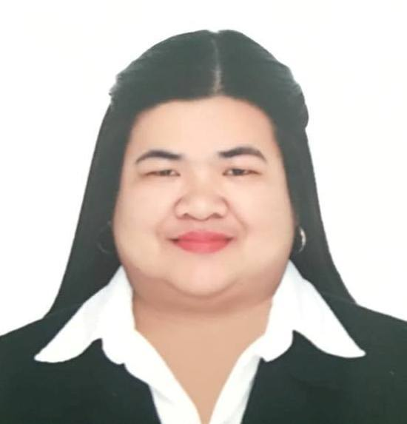
ENRIQUEZ

ENRIQUEZ.367267@2freemail.com

OBJECTIVES:
To gain employment that would fit my qualification, contribute all my capabilities in a continuously growing company, and to have opportunity to utilize my interest and abilities towards career development.

EMPLOYMENT HISTORY

TELLER COORDINATOR / ADMIN ASSISTANT JAN 2014 – MAR 2016
Customer Frontline Solutios Inc. (CFS)
MERALCO – Bacoor Business Center, Bacoor, Cavite, Philippines
Duties and Responsibilities: Provide general administrative and clerical support including mailing, scanning, faxing and copying to management. Maintain electronic and hard copy filing system. Perform data entry and scan documents. Prepare and modify documents including correspondence, reports, draft, memos and emails and maintain office supplies for department.
Responsible for the collection of payments for monthly electrical bills, installment payment agreement (IPA), bad debt, written-off, and pre-payments Responsible for the reconciliation of daily collection and submission of daily report to the Cash Revenue . Teller Coordinators perform many of the same task that regular tellers do. They are also the one who coordinates the work and schedule of tellers.

BRANCH TELLER (Front liner) DEC 2007 - DEC 2013
MERALCO-Outsourced Telleserve Corporation
MERALCO Rosario Business Center, General Trias Drive, Rosario, Cavite, Philippines
Duties and Responsibilities: Responsible for the collection of payments for monthly electrical bills, installment payment agreement (IPA), bad debt, written-off, and pre-payments Responsible for the reconciliation of daily collection and submission of daily report to the Teller Coordinator . Responsible for rendering excellent customer service

MONEY SORTER DEC 2005 - DEC 2006
East West Bank – Bacoor Branch
Aguinaldo Hi-way Niog, Bacoor, Cavite, Philippines
Duties and Responsibilities: Sorting of moneys, money arranged in a certain sequence based on the color of the money and detect counterfeit moneys.

OFFICE STAFF MAY 2005 – AUG 2005
HRD (S) PTE. LTD.
Cavite Economic Zone Rosario, Cavite, Philippines
Duties and Responsibilities: Estimate areas of Japanese house and we are the one responsible in computing the clean air that will comes in and dirty air that will go out of the house in a range that will good enough for the house and the people to be ventilated

EDUCATION:

College De La Salle University- Dasmariñas
Bachelor of Science in Business Administration
Major in Business Management
Year Graduated: 2005

High School Saint Augustine School
Tanza Cavite
Year Graduated : 2001

SEMINAR ATTENTED:

November 14,2009 “ Detecting Counterfeit Bills” by Ms. Remedios S.Ilagan facilitator of Bangko Sentral ng Pilipinas.

September 09, 2006 “ Counterfeit Detection Seminar” by BSP

March 04, 2005 “ English Profiency” by DLSUD Professors

January 17, 2005 “ Pre-Employment Seminar” by DLSUD Professors

September 24, 2003 “The E-Way of Doing Business” by DLSUD Professors

September 09,2003 “Leadership Through Effective Communication”

September 05, 2003 “ The Power to Succeed Competent”

SKILLS:

Computer Skills Have Knowledge in Microsoft Word, Microsoft PowerPoint, and Microsoft Excel.

Interpersonal Skills Ability to work with others and to win cooperation from people in a group

