curriculum vitae

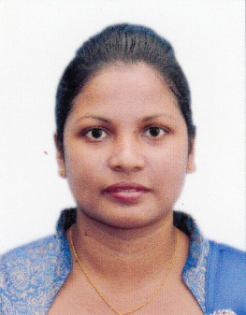
Personal information

Name | : | Geethani  Geethani.367274@2freemail.com

Objective
To employ my knowledge and experience with the intention of securing a professional career with opportunity for challenges and career advancement, while gaining knowledge of new skills and expertise.

Education

- Passed G.C.E. Ordinary Level Examination 2001
- Passed G.C.E. Advanced Level Examination 2004
- Bachelor of Arts (General)

University of Sri Jayawardenepura, Sri Lanka 2007-2011

Training Courses

- Professional English Part-time course at National Youth Services Council, Maharagama Training Centre 2006
- Followed BTEC. Dip in ICT at IDM Computer Studies (Pvt) Ltd. 2009
- Office Systems & Land Training at Land Commissioner General’s Department on 18.11.2013 – 20.11.2013
- Office Systems & File Maintainance Training at Land Commissioner General’s Department on 24.02.2014 – 25.02.2014
- Office Management & Development of Attitudes Training Course conducted by Sri Lanka Institute of Development Administration on 04.08.2014 – 08.08.2014
- Government Accounting Procedure Training Course conducted by Sri Lanka Institute of Development Administration on 17.10.2014
- Disciplinary Procedure Training Course conducted by Sri Lanka Institute of Development Administration on 18.01.2016 – 20.01.2016
- Quality Circle Training programme conducted by National Productivity Secretariat on 25.02.2016
- Maintain of Personal File Training Course conducted by Skills Development Fund Ltd under Ministry of Skills Development & Vocational Training on 05th & 06th December 2016

Working Experience

- Worked as an Employee 2004 November to 2007 at CBL Foods
- Worked as a Management Assistant at Sanasa Bank in Nawagamuwa
- Worked as a Graduate Trainee at Land Commissioner General’s Department 2012 to 2013
- Worked as a Development Officer at Land Commissioner General’s Department 2013 to present

Extra Curricular Activities

- Former Secretary of Sinhala Literary Association of the School
- Leader of the class grade 10 - 11 (2000-2001)
- Membership of the School Netball team
- Participated as an Examiner, Sri Lanka Technological Service Colonization Officer Grade III Efficiency Bar Exam held on 04.04.2015

Skills & Strengthens

- Good leadership of any society.
- Presentation skills along with well developed interpersonal and management skills.
- Ability to work independently and as a team.
- Ability to work under pressure.

I hereby certify that the particulars stated above are true and accurate.

