Curriculum Vitae
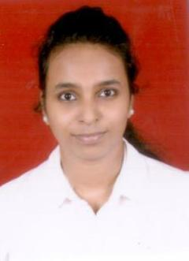
HARSHITA
HARSHITA.367288@2freemail.com
CAREER OBJECTIVES
To be an astute learner and the best performer in the organization. So that I can build an innovative career in the esteemed organization by using my skills and other significant talents.
INTERNSHIPS:
Company Name : ADORA GIFTS PVT LTD
Intern : International Sales & Marketing
December, 2016 to March,2017
RESPONSIBILITIES
- Handle online International sales and marketing.
- Promote products in International markets through B2B portals, along with team members and through email marketing and internet marketing.
- To meet sales targets set by the company and to keep record of all production samples and production orders.
- To keep track of all business emails and to follow up with the clients from inquiry to order and delivery to feedback.
- To take weekly reports from the team and monitor and guide their progress in achieving the targets.
- Maintaining and developing relationships with existing customers.
- Providing customers with quotations

Company Name : DIAL HEALTHCARE PVT LTD
INTERN :Marketing
April, 2016 – June, 2016
RESPONSIBILITIES
- Data Collection
- Data Management
- Handling purchase and sales records
- Stock Audit
- Field Work
- Handling Projects
PERSONAL SKILLS
- Socially adaptable with changing environment.
- Willingness to learn new things
- Strong communication and Presentation Skills.
- Creative and the ability to solve problems.
- Excellent time management and soft skills.( National Certificate in ‘MODULAR EMPLOYABLE SKILLS”)
- Excellent follow-up skills and the ability to handle pressure and meet deadlines
- Working knowledge of MS Office (Word, Excel, PowerPoint etc.)
- Good at organizing events(organized events in college and worked as an event coordinator for events)

ACADEMIC QUALIFICATION
M.B.A + PGPM  2015-2017 | Pondicherry University
Bachelor of Management studies  2012-2015 | Mumbai University
H.S.C (Commerce)  2010-2012 | Mumbai University

LANGUAGES
- English
- Hindi
- Marathi
- Tulu

PERSONAL
Date of Birth : 21-12-1994
Nationality : Indian
Marital Status : Single

