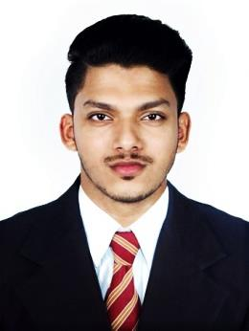
Sahal

Sahal.367289@2freemail.com

CAREER SUMMARY

A Business Management degree graduate and a Social Media Marketing diploma holder with previous experience in Sales/Customer Service and also managing, creating content and marketing social media account for private business.

EDUCATIONAL QUALIFICATION

COURSE | COLLEGE/INSTITUTION | YEAR OF PASSING
SOCIAL MEDIA MARKETING DIPLOMA | SHAW ACADEMY | 2016
BBM DEGREE | ST. ALOYSIUS COLLEGE, MANGALORE | 2016
PUC/12th | SREE GOKULAM PUBLIC SCHOOL, VADAKARA | 2012

WORK EXPERIENCE

- Company - Monarch International, India
Period - 10th June 2016 - 10th February 2017
Role – ‘Sales Executive’

RESPONSIBILITIES:

- To research about different sales options and analyzing them.
- To sell the company products/services by creating contacts and further making relationships with the prospects.
- To provide proper information, guidance, and support to the clients/customers hence enhancing the relationships.
- To recommend solutions to any problems faced by the clients.
- To team up with co-workers to ensure proper client/customer service.

SKILLS & QUALITIES

- 8 months of experience in Sales and Customer Service.
- Ability to manage, create content and market social media accounts on various social media platforms.
- An efficient natural communicator with excellent interpersonal skills.
- An excellent team player and good coordinator.
- Self-motivated, hardworking and a quick learner.
- MS office, social media, software/tools installation, Internet and e-mail.

INTERESTS

Fashion, social media, photography, travel and performing arts.

EXTRACURRICULAR ACTIVITIES / ACHIEVEMENTS

- Among Top 10 singers –‘Musical Evening’ at St. Aloysius College.
- Participation in various Inter-College Fests and Cultural Events.
- CBSE Kerala State Level Winner – Mime Act.
- CBSE Kerala State Level Winner – Oppana Dance.

I hereby declare that the above furnished information is correct to best of my knowledge and belief.

