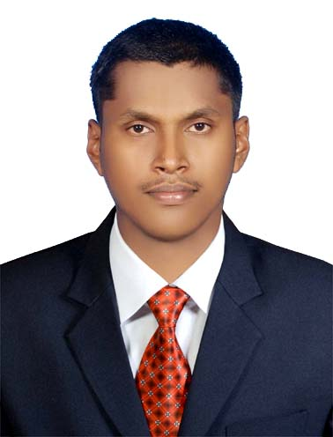

CHETHAN
CHETHAN.36729@2freemail.com

Cash Management

Accounting Knowledge

CAREER OBJECTIVES AND GOALS

A hardworking and highly motivated individual with 5 years of work experience, I am competent and reliable and able to work well both independently and in a team in Finance and Accounts department. Quick to learn and used to adapt to high pressure and tight deadlines while remaining both good humor and accurate.

EXPERIENCE
Assistant Manager Accounts,
M/S Prakash Retail Pvt Ltd , Dharwad , India
14-November-2011 to 21-March-2015

Accomplishments

- Handling cash transactions in lump sum and tallying perfectly.
- Manage day to day cash transactions of the company
- Ensuring company cash flow and doing prompt payments to suppliers.
- Maintain Account Receivable and Payable Ledgers.
- Record sales transactions in the system on a daily basis and keep track on Account Receivable.
- Prepare Debtors list by using excel and constantly follow up for payments.
- Perform daily accounting transactions such as creating and posting vouchers.
- Check daily Bank Reconciliation statements of all bank accounts maintained and resolve any differences in a timely manner.
- Prepare MIS report on daily basis.
- Card sales reconciliation and handle all cash related transactions. Tally daily cash and cheque deposits checking with the online bank statements.
- Prepare financial reports such as Trial Balance, P & L A/c and Balance sheet with the help of Accounts Manager.
- Maintain PDC and reconciliation of postdated and current dated cheques.
- Co ordinate with bank authorities, auditors and ensure proper compliance with all statutory regulation and company policies and procedures.
- Prepare vouchers and Cheques for receipts and payments.
- Monitoring and handling the day to day credit sale transactions of store.
- Passing monthly provision entries of all expenses.
- Preparation of monthly revenue generating reports like delivery charges, Service charges and installation charges collection and reporting to top management.
- Petty cash payments.

Reporting to Senoir mangers

EffectiveCommunication Skills

Excellent Accounting Skills

Willingness to Learn

Leadership Skills

- Reconciliation of ledger and sending balance confirmation to parties
- Reconciliation of interbranch entries, gift voucher and scratch card entries.

Document Controller
Al Turki Enterprises L L C, Al Buraimi,Sultanate of Oman
01-April- 2015 to 07-September-2015

Accomplishments
- Register, log, distribute, track, issue, maintain and control office and site project documents and drawings.
- Coordinate the activities of Document Control, including distribution of documents, tracking and reporting on document review progress.
- Perform all computer operation/encoding as instructed by my immediate superior.
- Perform the necessary filing.
- Ensure accessibility, traceability and accuracy of documents
- Reporting on the performance of the document control system for review and as a basis for improvement of the documents control system.
- Ensure that Project Team and contractors comply with the document management system process and procedures.
- Work closely and liaise with contractors’ document control group in all matters relating to document control.
- Maintain document logs for correspondence, material approval submittals, shop drawing, RFI (incoming & outgoing).
- Receiving and distributing all documents. Preparation transmittal sheets for Inspection Requests, Material & Shop drawing submittals and Filing .

Assistant Manager Accounts and Admin
M/S Prakash Retail Pvt Ltd , Bangalore , India
01-October- 2015 to 11-April-2017

Accomplishments

Trainned in Oracle System

Flexibility and Adaptability

Quick Learner

- Handle a team of 30 staffs including Associates, Sales officers and Sale Executives.
- Renewal of labour License, maintaining of Attendance Register, Bonus Register and other Store documents.
- Arranging company product demonstration programme to customer
- Maintaining ISO Records.
- Annual Maintenance Contract ( Like Lift, Generator and Air Condition),
- Look after daily showroom maintenance (Cleaning, Security, Safety and Lighting),
- Stationery Management,
- Arranging company product training programme to associates.
EDUCATION
- Master in Business Administration in Finance at Sahyadri College of Engineering & Management affiliated to Vishveshwaraiah Technological University, Belgaum. Completed MBA with an aggregate of 64% in the year 2011.

- Bachelor of Business Management at St Philomena College, Puttur affiliated to Mangalore University. Completed BBM with an aggregate of 64% in the year 2009.

- PUC at St Philomena PU College, Puttur affiliated to Karnataka State Board. Major Subjects: Statistics, Economics, Business
Studies, Accounts. Completed PUC with an aggregate of 74%
in the year 2006.

- SSLC at St Philomena High School, Puttur. Completed SSLC with an aggregate of 69% in the year 2004.

IT SKILLS
- Operating systems: Windows XP, Windows Vista, Windows7
- Knowledge on: MS Word, MS Excel ,MS PowerPoint, Tally 7.2 ,Visual Basic ,Oracle ,ERP and Internet Applications

PERSONAL INFORMATION
Date of Birth: 12th Sept 1988
Nationality: Indian
Marital Status: Single
Passport Status: 28-Feb-2021
Languages known: English,Hindi,Kannada,Malayalam & Tulu

