Sarosh
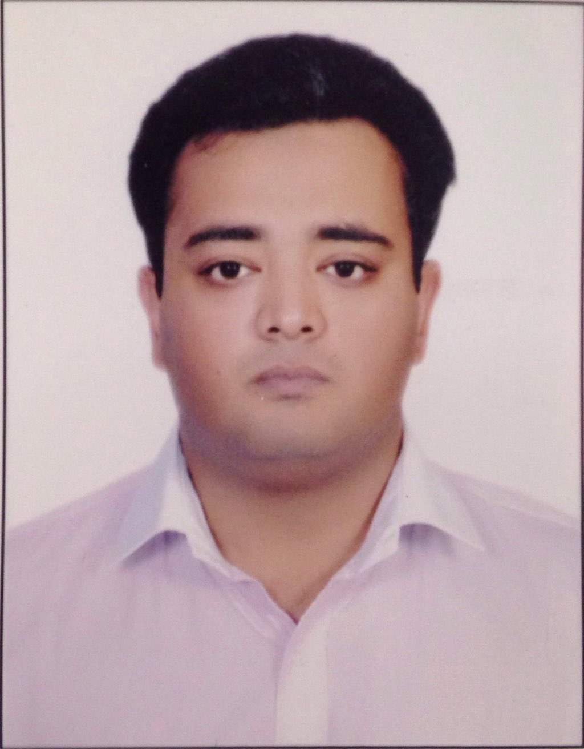
Sarosh.367317@2freemail.com

Summary
  - A dynamic professional with a rich experience in various verticals, like Business Development, Product Management, Brand Management, Below the Line Activations and Team Management.
  - A strategic planner & implementer with demonstrated abilities in conducting innovative promotional schemes and brand building activities.
  - Abilities in supporting organisational growth through effective marketing & communication initiatives.

Organisational Experience
Abu Dhabi Islamic Bank (August 2016 - February 2017); Abu Dhabi (U.A.E.)
Profile: Projects Coordinator (Corporate Social Responsibility/ Innovations/ Events and Sponsorships)
Key Responsibilities: Innovation, Event Planning, Sponsorships, Initiatives.
Highlights:
- Assisting the CSR Committee in developing, managing and altering social responsibility policies.
- Sponsorships of CSR activities, includes awards nights Exhibitions etc.
- Delivering events on time, within budget, that meet expectations.
- Scanning various social initiatives and presenting them to the CSR Committee.
- Preparing budgets on Quarterly and Yearly basis.
- Preparing Post Event Reports.

Red and Yellow (September 2014 till March 2016); New Delhi (India)
Profile: Business Development Manager - Sponsorship and Promotions - Marketing Operations - Event Management
Key Responsibilities: Generating Clients, Clients Servicing, Sales, Events & Promotions, On-ground execution and merchandising, Strategy and financial planning.
Highlights:
- Proposed potential business deals by contacting potential partners; discovering and exploring opportunities.
- Closed new business deals by coordinating requirements; developing and negotiating contracts; integrating contract requirements with business operations.
- Found new ways to get the visibility for all the activities.

S.F. ADVERTISING (JUNE 2013 Till AUGUST 2014); New Delhi (India)
Profile: Marketing/Sales Manager.
Key Responsibilities: Events and Promotions, On Ground Execution & Client Servicing
Highlights:
- Obtained, retained and handled BTL activations and Marketing strategies from clients.
- Responsible for finding new ways to get the visibility for all the activities.
- Responsible for liaising with marketing and PR colleagues to promote the event
- Responsible for outdoor and indoor branding.
- Responsible for organising Corporate Conferences.

S.F. ADVERTISING (January 2011 Till May2013); New Delhi (India)
Profile: Event Manager
Key Responsibilities: Events and Promotions, On Ground Execution
Highlights:
- Day to day event planning and management.
- Onsite management and overall responsibility.

Roles and Responsibilities
Over 5+ years of progressive experience in Event Management, Corporate Social Responsibility, and Product Management

Key Highlights:

- An integral part of initiatives such as, ADIB Bazaar, EFICA (Ethical Finance Innovation Challenge and Awards) and Mass Weddings.
- Held various Blood Donation Camps, with Abu Dhabi blood bank and Dubai blood bank.
- Preparing Post Event Reports, and Invoices.
- Maintaining the projects well under the allotted budget.
- Tie-up with VODAFONE, IDEA and AIRTEL for branding of Mini Stores in Delhi-NCR.
- Tie-up with VODAFONE for Branding and Promotional Marketing in IITF (India International Trade Fair) in 2012, 2013 and 2014.
- Tie-up with SI (Solo sun International) for Brand building.
- Tie-up with VODAFONE FOR Branding and Promotional Marketing in IPL (Indian Premiere League) in 2012, 2013, 2014 and 2015 and in IBL (Indian Badminton League) 2013
- Obtained and Delivered a CSR project (HELP A CHILD) for Vodafone in 2013
- Tie-up with CHAAYOS for Brand building, and setting up Cafes in Delhi-NCR.
- Tie-up with VIVO MOBILES Brand building, and setting up Stores in Delhi-NCR.
- Tie-ups with PEPE JEANS, TATA SKY, ASIAN TILES, HEWLETT-PACKARD for setting up stores and Branding in Delhi-NCR.

Educational qualification
- Bachelor in Science, Animation and Multimedia (2010-2013) from Mahatma Gandhi Univ.
Cumulative major GPA: 3.5/4

Personal particulars
Languages: English (fluent) and Hindi (native)
Well versed in MS Office (Word, Excel and PowerPoint), MAC (Keynote, Pages and
Numbers), Adobe Photoshop and Adobe Premiere-Pro.
Date of Birth: 07/10/1989

