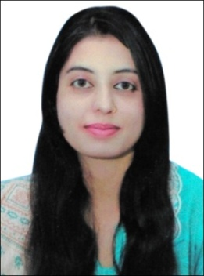
Huma
Huma.367325@2freemail.com

Career Goal
“To obtain a respective career in Customer Services, Operations and Management field, to apprehend my true potential by working in an environment that is conductive to hard work and creative thinking and to excel in a growth oriented organization by practicing all the technical, non-technical knowledge & experience I have”.
Educational Background
- Achieved Bachelor in Education from the Sargodha University, Punjab in the year of 2016 at Education as the major.
- Achieved Master in Business Administration from the Virtual University of Pakistan in the year of 2012 at Human Resource Management as the major.
- Achieved Bachelor in Commerce from the Punjab University, Lahore in the year of 2004 at Information and Technology as the major.
EXPERIENCE
Warid Telecom Pvt. Ltd (JAN-2015 till Date)
Working as Office Coordinator

- Follow office workflow procedures to ensure maximum efficiency
- Maintaining MIS, reports and records with effective filing systems and reconciliation.
- Support sales team with various administrative tasks (Redirecting Calls, Disseminating Correspondence, Scheduling Meetings, Promotions etc.)
- Performing basic book keeping activities, billing, In-house Sale and update the accounting system.
- Dealing and assisting customer/Vendor complaints or issues and relationship management
- Monitoring office supplies inventory and place orders

Kashf Microfinance Bank Limited (Oct 2009 to April 2013)
Worked as Teller/Customer Service Officer

- Cash Management & Monitoring
- Daily Balancing & Reconciliation of Cash
- Responsible for Receipts/Payments of cash
- Maintaining Cash Record & its reporting
- Remittances
- Account Opening
- Disbursement Of Loan files

Bank Al-Falah Limited (June 2005 to October 2009)
Worked as Teller/Customer Service Officer

- Preparing Daily Vouchers
- Daily Voucher Checking
- HO Reconciliation
- Posting of Inward & Outward Clearing
- Lodgment of IBC & OBC Cheque Collection
- Back up in Account Opening & Also Work As Greeter

EXPERTISE
1. Professional Skills
- General Administration
- Team Player with Leader ship Skills
- Customer Services
- Office Management
- Organizing Events and meetings
- Target Oriented

2. Computer Skills
- Certificate Course in Office Management.
- MS Office (Ms Word, Ms Excel, Ms Power Point, Ms Access)

3. Language Skills
- English, Urdu, Hindi, Arabic (Beginner)

PROFESSIONAL COURSES
- Customer Services – Kashf Microfinance Bank Ltd.
- Personal effectiveness - Bank Al-Falah ltd.
- Air Hosting Diploma – Karachi, Pakistan.

PERSONAL INFROMATION
D.O.B: 7th June, 1983
Marital Status: Married
Religion: Christian
Nationality: Pakistan
Visa Status: *Visit (10 July 2017)

INTRESTS
Reading Newspaper, Current Affairs, Reading Books

REFERNCE: Will be provided, if required.

