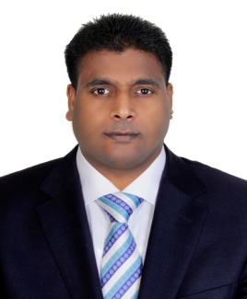
Curriculum vitae
Ramakrishna
Ramakrishna.367330@2freemail.com

____________________________________________________________________________________________

Objectives:
A career in reputed organization with challenging opportunities for growth and shoulder in responsibilities where I can use my knowledge, experience, technical skills and leadership skills to grow up in an esteemed organization with intent to serve the company in upgrading manner.
Work experience:

- I worked as a Seiner CHEF DE PARTIE KITCHEN IN CHARGE IN CIRCLE CAFÉ CASUAL DINING from Feb-2016 to 05 March-2017.
- Worked as a CHEF DE PARTIE IN CIRCLE CAFÉ from June-2015 to Jan-2016.
- Worked as a DEMI CHEF DE PARTIE IV QUATTRO EUROPIAN RESTAURANT FINE DINING (French, Spanish & Italian) from 18TH June-2014 to19th June 2015.
- Worked as a COMMIE 1 IN AMIKA RESTAURANT IN H HOTEL FINE DINING from 1st august 2013 to 30th may 2014.
- Worked as COMMIE 1 IN RUTHS CHRIS STEAK HOUSE FINE DINING from 20th Feb 2012 to 20th July 2013.
- Worked as as COMMIE 2 IN BIN HENDI ( Japengo café) from Feb 2010 to January 2012

Duties & Responsibilities:

- Maintains the cleanliness of the food production area.
- Checks all the kitchen stocks before and after the operation.
- Makes sure the expiration date is mentioned on each and Every items.
- Follows the first in first out regulation and assist team members in their assigned tasks as well as follows the company policy rules, heads & superiors instruction.

Strengths:
- Confident, willing to learn, friendly attitude.
- Can speak both English and Hindi.
- Physically fit.
- Hard working person.
- Can initiate TEAM WORK.

Educational Attainment:

- intermediate (12- grade)

Skills
Microsoft office

Certification
PIC (Person in Charge)

Personal Details:

Date of Birth: April O5, 1977
Place of Birth: India (AP)
Gender: Male
Marital Status: Married

Visa Status: Visit Visa
Visa Expiry date: August 03
Religion: Hindu

Declaration:

I hereby declare that the above details are true and correct to the best of my knowledge and belief.

