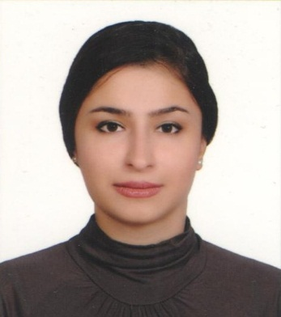
Name: Simin Simin.367334@2freemail.com

Profile: A hardworking, committed and enthusiastic person in my carrier, with over four years’ experience of working in business area, paying attention to my duties consciously, with interpersonal skills and ability.

Education and Qualifications:

- Accounting Courses (300 Hours )
- Advanced Letter Of Credit Courses (120 Hours )
- Bachelor Degree in Tourism Management (Ragheb-Esfahani University )

Work Experiences:

- Ofoq Stone Company - 2015-Up to Now
Commercial Manager
- Resolving contractual and commercial problems
- Discovering areas that are not in-keeping with regulation practices
- Offering direction and instruction
- Risk assessment
- Reviewing and developing operational process flows
- Ensuring that all stockholders understand and adhere to contractual obligations
- Ensuring that the financial aspects and impact of a contract are clear to all parties
- Overseeing financial KPIs

- FMI Group (The branch of Chodan Sazan Co ) Consultative Foreign Purchase
2013-2014

-Chodan Sazan Co., Foreign Trade
(Manufacture of Cast Rolls & Sleeves) (Import of Raw Materials)
2011-2013
No 136, 4th St, Jay Industrial zone, Esfahan, Iran.

Skills and Proficiencies:

Skill Name Skill Level
- Natural Stone Export Expert
- Registration of the purchased product at Iran Chamber of Commerce Expert
- .Preparing Documents & Follow up for releasing goods from customs. Expert

- Foreign Purchase Consultative Expert
- Client Relation /Customer Care Expert
- Accounting Basic
- Opening Letter of Credit & Money Draft Expert
- English Language Expert
- Arabic Language Intermediate
- Turkish & French Language Basic
- Persian Language Mother Language
- Power Point Presentation Expert
- MS Office (Word ,Excel ,PowerPoint ,Access ) Expert
I look forward to an interview and hope to hear from you at your earliest convenience.

