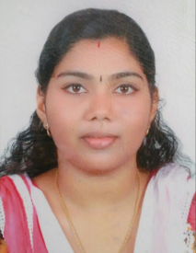 | RAIJY  RAIJY.367352@2freemail.com
CERTIFIED MEDICAL CODER
CAREER OBJECTIVE

Looking for a challenging role in Medical Coding in an esteemed organization where I can utilize my extensive knowledge in Medical Coding, computer skills, organizational abilities, communication skills and patient service for the effective growth of the organization.

PROFILE AT A GLANCE  - A budding professional with extensive conceptual knowledge of Medical Codes and Standards.  - Possess excellent knowledge of HCPCS for medical diagnosis and procedures.  - Well versed with coding techniques and guidelines of Medical Coding and has comprehensive knowledge of Anatomy, Physiology and Medical Terminology.  - A keen communicator with excellent interpersonal skills. Prudent, disciplined, self-motivated and quick leaner with strong analytical abilities.  - Technical proficiency in using MS Office suite (Word, Excel & PowerPoint) and Windows OS. |  |  | AREA OF EXPERTISE  ICD-9-CM Coding  ICD-10CM Coding  HCPCS & CPT Coding  Modifiers  Medical terminology  Medical Guidelines  Anatomy & Physiology
ACADEMIC CREDENTIALS

- Certified Professional Coder (CPC) from American Association of Professional Coder (AAPC) Membership Id: 01524759

- Master of Business Administration – Finance from Bharathiyar University, Tamil Nadu, India in 2015.

PERSONAL PROFILE

- Date of Birth: 27th March 1987  - Nationality: Indian  - Marital Status: Married |  | - | Visa Status: Family Visa  - Language Proficiency: English, Malayalam & Hindi
DECLARATION

I hereby declare that all the information furnished in this document is true to my knowledge and belief.

